# [A person with glasses and a yellow triangle Description automatically generated](https://github.com/Dare-marvel/)Consumer Electronics Previous Year’s Questions Answers - Made by [Dare-Marvel](https://github.com/Dare-marvel/)

# ESE MAY/JUNE 2019

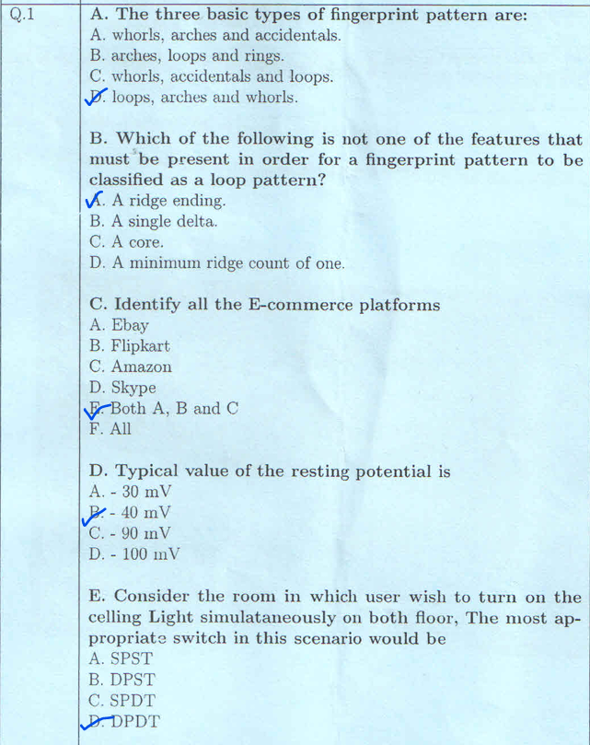

## Define the following terms with respect to respiratory measurements.

## A. Tidal Volume

## B. Expiratory Reserved Volume

## C. Inspiratory Reserved Volume

## D. Force Expiratory Volume in 1 sec (FEV1)

## E. Vital Capacity

**Respiratory Measurements**

**Definitions:**

**A. Tidal Volume:** This is the amount of air that is normally inhaled or exhaled in one breath. It's the volume of air that moves in and out of the lungs during quiet breathing.

**B. Expiratory Reserve Volume:** This is the maximum amount of air that can be forcibly exhaled after a normal exhalation. It represents the extra air that can be expelled beyond the tidal volume.

**C. Inspiratory Reserve Volume:** This is the maximum amount of air that can be forcibly inhaled after a normal inhalation. It's the extra air that can be taken in beyond the tidal volume.

**D. Force Expiratory Volume in 1 sec (FEV1):** This is the maximum amount of air that can be forcibly exhaled in one second. It's a measure of lung function and is often used to assess obstructive lung diseases like asthma or COPD.

**E. Vital Capacity:** This is the maximum amount of air that can be exhaled after a maximum inhalation. It's the sum of the tidal volume, inspiratory reserve volume, and expiratory reserve volume. Vital capacity represents the total lung capacity that can be used.

## Describe operation of PAL System with neat labelled diagram

<https://www.ques10.com/p/26475/draw-the-block-diagram-of-pal-tv-receiver-and-expl/>

<https://www.ques10.com/p/26478/explain-the-features-of-pal-system-explain-pal-cod/>

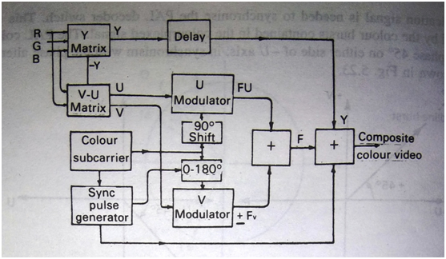

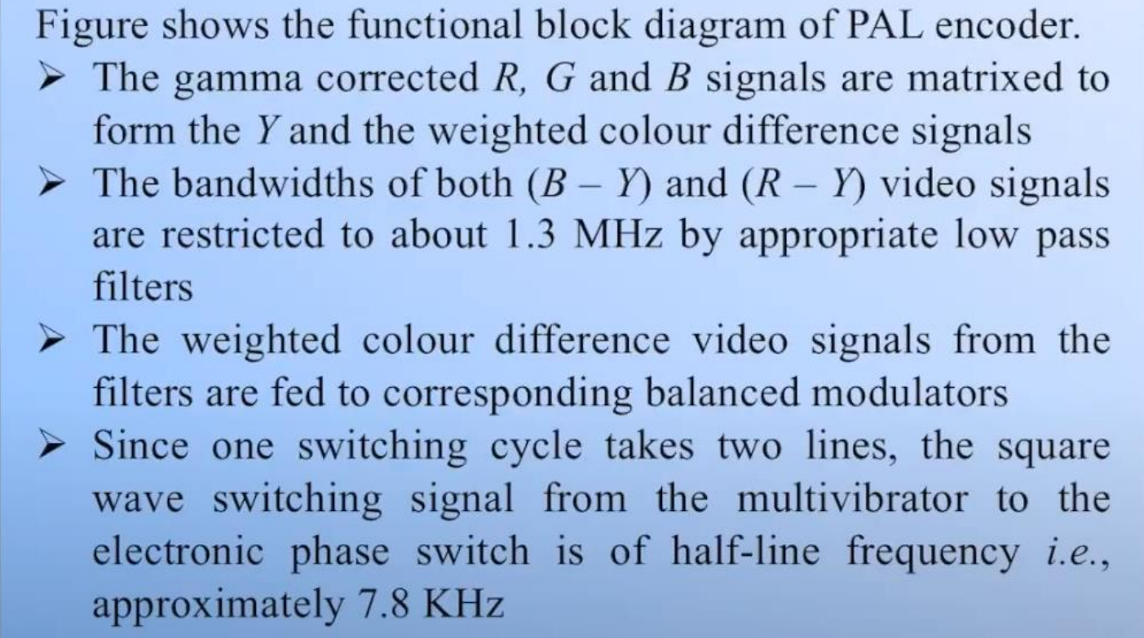

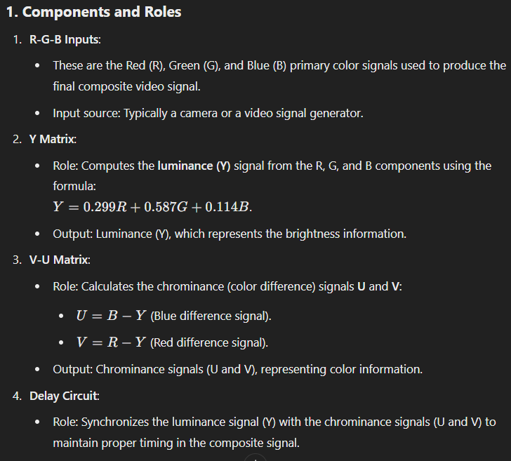

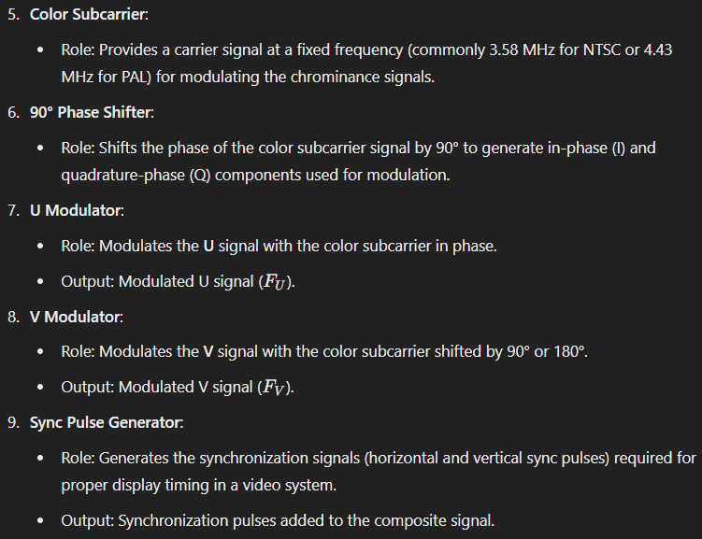

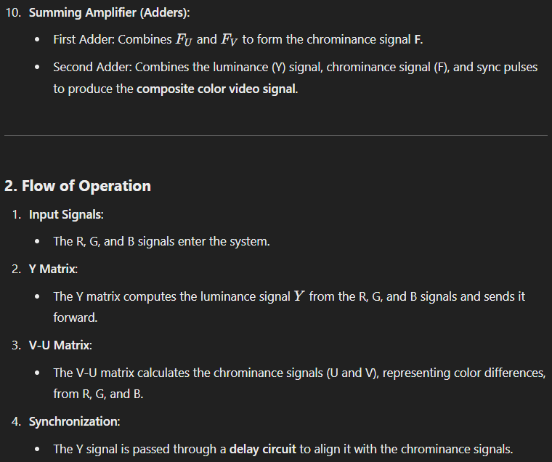

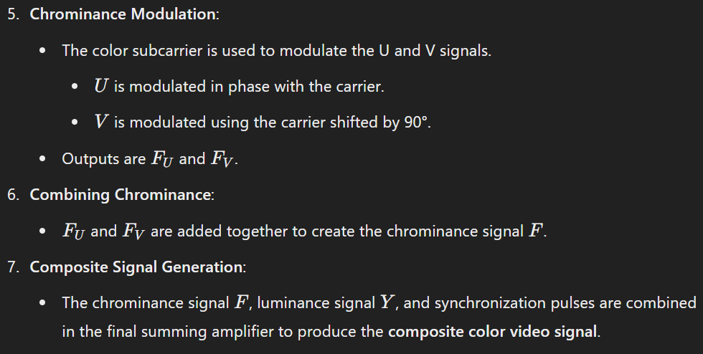

## How Noise Cancelling headphones works in removal of outside noise. Mention operating principle of the two types of Noise Cancelling headphones available in market.

Noise cancelling headphones are designed to reduce unwanted ambient noise, allowing you to focus on your audio content. Here's how they work, with a breakdown of the two main types:

**1. How Noise Cancellation Works:**

* **Sound as Waves:** Noise is simply sound waves traveling through the air. Noise cancelling headphones work by generating sound waves that are out of phase with the incoming noise waves.
* **Destructive Interference:** When these out-of-phase sound waves meet, they interfere with each other, effectively cancelling out the noise.

**2. Types of Noise Cancelling Headphones:**

**A. Passive Noise Cancellation:**

* **Principle:** This type of noise cancellation relies on the physical design of the headphones to block sound.
* **Mechanism:** Passive noise cancellation uses earcups that fit snugly over your ears, creating a physical barrier that prevents external sound from reaching your eardrums.
* **Effectiveness:** While effective for reducing some noise, passive noise cancellation is less effective for blocking higher frequency noises or very loud sounds.
* **Examples:** Many over-ear headphones offer some degree of passive noise cancellation, but they do not have active noise cancellation features.

**B. Active Noise Cancellation (ANC):**

* **Principle:** This type of noise cancellation actively generates sound waves to cancel out ambient noise.
* **Mechanism:**
  + **Microphones:** ANC headphones have microphones built into the earcups that detect incoming noise.
  + **Signal Processing:** These microphones send the noise signal to a processor that generates a mirror image of the noise wave but shifted 180 degrees out of phase.
  + **Speaker Output:** This out-of-phase sound wave is then played through the headphones' speakers, cancelling out the original noise.
* **Effectiveness:** ANC headphones can be highly effective at reducing a wide range of frequencies, including low-frequency noise (e.g., airplane engine noise).
* **Examples:** Many high-end over-ear headphones offer ANC, and it's becoming increasingly common in even some in-ear headphones.

**3. Advantages of Noise Cancelling Headphones:**

* **Reduced Noise:** ANC headphones dramatically reduce ambient noise, creating a quieter listening experience.
* **Improved Audio Clarity:** By eliminating noise, ANC headphones allow you to hear your music or other audio content more clearly.
* **Focus and Concentration:** ANC headphones can help you focus on your tasks, whether you're working, studying, or traveling.
* **Stress Reduction:** Noise cancellation can reduce stress and fatigue associated with loud environments.

**4. Considerations:**

* **Battery Life:** ANC headphones require power, and battery life can vary depending on the model.
* **Cost:** ANC headphones are generally more expensive than passive noise-cancelling headphones.
* **Sound Quality:** The quality of the sound produced by ANC headphones can vary, so it's essential to listen to different models before making a purchase.

## Describe operation of LCD display in detail

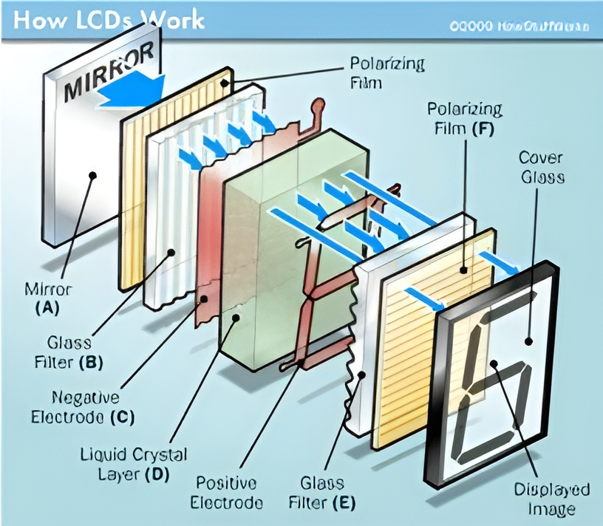

**How LCDs Work:**

1. **Principle**:
   * An electrical current is applied to the liquid crystal molecule, causing it to untwist.
   * This untwisting changes the angle of light passing through the polarized glass, altering the angle of the top polarizing filter.
   * A small amount of light passes through the polarized glass in a specific area of the LCD, making that area dark.
2. **Construction**:
   * **Mirror**: A reflected mirror is placed at the back of the LCD.
   * **Electrode Plane**: Made of indium-tin-oxide, positioned on top.
   * **Polarized Glass**: With a polarizing film, placed at the bottom.
   * **Common Electrode**: Encloses the entire LCD region with the liquid crystal matter above it.
   * **Second Glass Piece**: Includes an electrode in the form of a rectangle at the bottom and another polarizing film on top. Both pieces are aligned at right angles.
3. **Operation**:
   * **No Current**: Light passes through the front, reflected by the mirror, and bounces back.
   * **With Current**: The liquid crystals between the common-plane electrode and the rectangle-shaped electrode untwist, blocking light from passing through. The rectangular area appears blank.

Now, let's walk through the step-by-step operation of an LCD:

Light enters the front of the LCD, passing through the cover glass and the first polarizing film.

The light then travels through the glass filter, where its direction is controlled.

The positive electrode applies an electrical charge to the liquid crystal layer, causing it to twist and change the polarization of the light.

The light then passes through the second polarizing film, which is oriented perpendicular to the first. Only light waves that have been properly twisted by the liquid crystal can pass through this second polarizer.

The light reflects off the mirror at the back of the LCD and travels back through the stack of layers.

The final displayed image is created by the light that has successfully navigated the entire LCD structure.

**How LCD Utilizes Liquid Crystals & Polarized Light:**

1. **Concept**:
   * An LCD TV monitor uses the concept of sunglasses to operate its colored pixels.
   * A bright light behind the LCD screen shines toward the observer.
2. **Pixel Structure**:
   * Millions of pixels, each with sub-pixels colored green, blue, and red.
   * Each pixel includes a polarizing glass filter at the back and front, arranged at 90 degrees, making the pixel look dark normally.
3. **Liquid Crystal Control**:
   * A small twisted nematic liquid crystal between the two filters is controlled electronically.
   * **Turned OFF**: Light passes through 90 degrees, allowing light to pass through the polarizing filters, making the pixel bright.
   * **Activated**: Light is blocked by the polarizer, making the pixel dark.
4. **Transistor Control**:
   * Each pixel is controlled by a separate transistor, turning ON and OFF multiple times per second.

<https://www.elprocus.com/ever-wondered-lcd-works/>

## Explain operating principle of ink jet printer with diagram

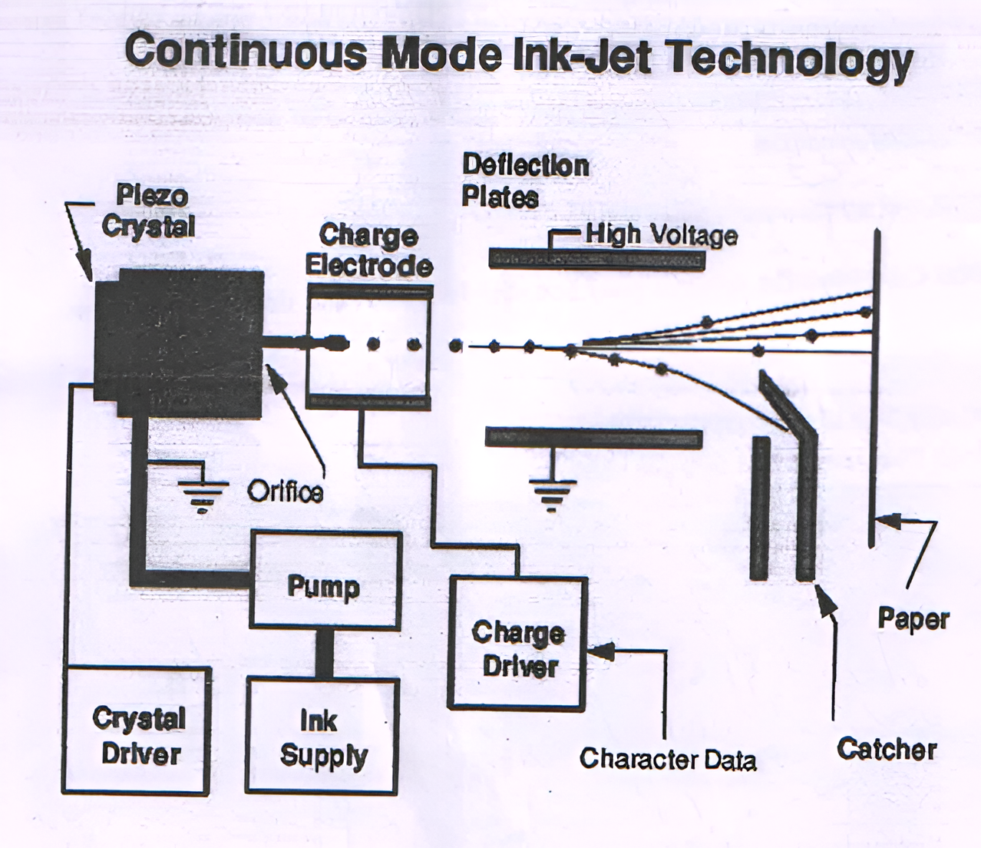

The core of the ink-jet technology is the piezo crystal. When an electrical charge is applied to the piezo crystal, it deforms slightly, which creates a pressure wave that ejects a droplet of ink through the nozzle or orifice. This is known as the piezoelectric effect.

The charge electrode serves to apply the necessary electrical charge to the piezo crystal, causing it to deform and eject the ink droplet. The high voltage supply provides the electrical power to drive this process.

The ink supply feeds the liquid ink into the print head. The pump helps circulate and pressurize the ink so it can be efficiently ejected through the nozzle.

The deflection plates create an electrostatic field that can bend the trajectory of the ink droplets as they are fired out of the nozzle. This allows the system to precisely aim the droplets and control where they land on the paper.

The character data input provides the digital instructions that tell the print head which droplets to fire and when, in order to form the desired text or image on the paper.

The catcher collects any stray or unused ink droplets that don't make it to the paper surface. This helps conserve ink and maintain print quality.

Overall, the continuous mode ink-jet technology relies on the precise control of electrically-driven piezo crystals, ink pressure and flow, electrostatic deflection, and digital pattern data to accurately deposit ink droplets onto the print medium. This allows for high-quality, high-resolution printing without the need for a traditional print mechanism.

<https://issuu.com/er.ramsaranbanger/docs/working_of_inkjet_printer>

# MSE 7/03/24

## With the neat diagram and graph, show how a tactile electrostatic clutch with high force density is used in a kinesthetic feedback glove?

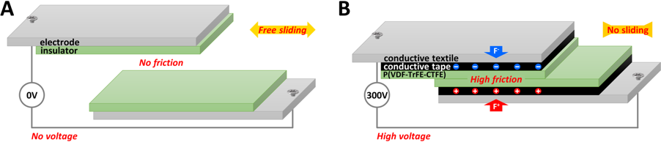

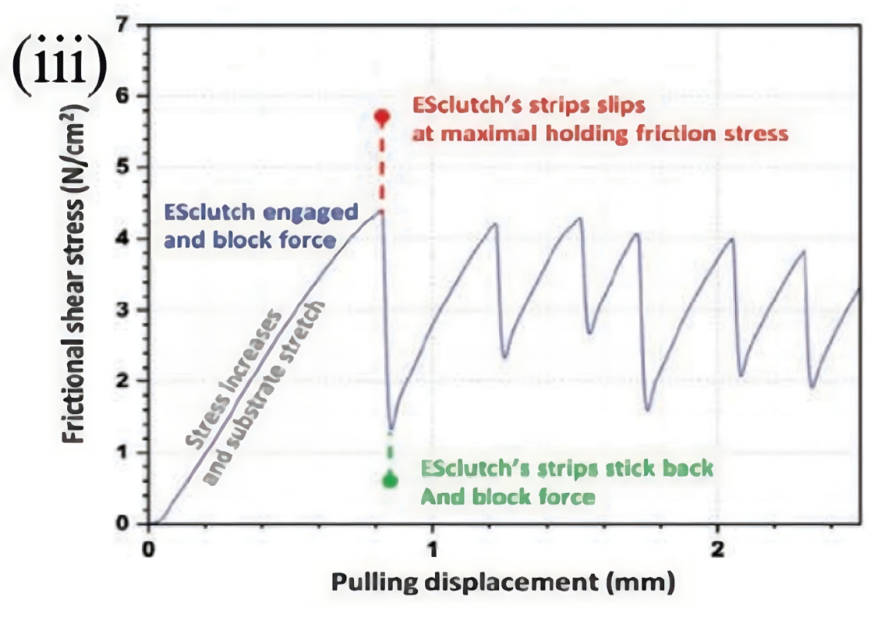

A tactile electrostatic clutch (ESclutch) with high force density is used in a kinesthetic feedback glove to:

* **Provide tactile feedback**: The clutch blocks or hinders motion, which provides a realistic sensation of virtual objects having different stiffnesses. For example, a virtual sponge might feel softer than a virtual brick.
* **Enable interaction with virtual objects**: The clutch allows for enhanced interaction with virtual objects.
* **Adapt to different hand sizes**: The clutch can be fixed to a wristband using Velcro, allowing for quick adjustment of the clutch module's position.
* **Be integrated into complex shapes**: The clutch can be integrated into complex shapes with small radius of curvature.
* **Be worn comfortably**: The clutch is highly flexible and light, making it suitable for wearing.

Components:

1. Electrode Insulator:
   * This is a smooth, frictionless surface that acts as the foundation for the clutch mechanism.
   * It provides a low-friction interface for the conductive tactile to slide against.
   * The insulator material ensures there is no direct electrical contact between the tactile and the electrode.
2. Conductive Tactile:
   * This is the key "clutch" material that can grip or release based on the applied voltage.
   * It is made of a conductive fabric or material that can generate an electrostatic force when a voltage is applied.
   * The conductive tactile needs to be flexible and conformable to allow it to be integrated into a glove design.
3. High Voltage Source:
   * This is the power supply that generates the high voltage (e.g., 300V) required to activate the electrostatic clutch.
   * It can be a compact, lightweight module that is embedded within the glove or connected externally.
   * The voltage source needs to be carefully designed to provide the necessary high voltage while ensuring user safety.

Step-by-step Explanation:

1. In the "No Voltage" state, the conductive tactile can slide freely over the electrode insulator with minimal friction. This allows the user to move their hand naturally without any resistance or haptic feedback.
2. When the user interacts with a virtual object that requires tactile feedback, the high voltage source is activated. This applies a high electric potential difference between the conductive tactile and the electrode insulator.
3. The high voltage creates a strong electrostatic attraction between the tactile and the insulator. This generates a significant normal force (or gripping force) that prevents the tactile from sliding freely.
4. The increase in normal force, as shown in the graph, directly translates to an increase in friction between the tactile and the insulator. This higher friction provides a sensation of resistance or texture to the user's hand.
5. By strategically placing these electrostatic clutch elements in specific regions of the glove, the designer can create localized areas of high friction and resistance. This allows for a more nuanced and realistic simulation of various virtual object properties.
6. For example, when the user's hand touches a rough, textured virtual surface, the corresponding clutch elements in the glove can be activated to generate a high-friction, resistive sensation. Conversely, when the hand interacts with a smooth, slippery object, the clutches can be deactivated to provide a low-friction, effortless sliding motion.
7. The ability to precisely control the normal force and friction perception gives users a tangible, kinesthetic experience that closely matches the physical interactions they would have with real-world objects. This significantly enhances the realism and immersion of the virtual environment.
8. The designer can further refine the haptic feedback by modulating the voltage level, the pattern of clutch activation, and the placement of the clutch elements within the glove. This allows for a wide range of tactile sensations to be recreated.

## B) Compare LCD and LED Displays.

<https://www.geeksforgeeks.org/difference-between-led-and-lcd/>

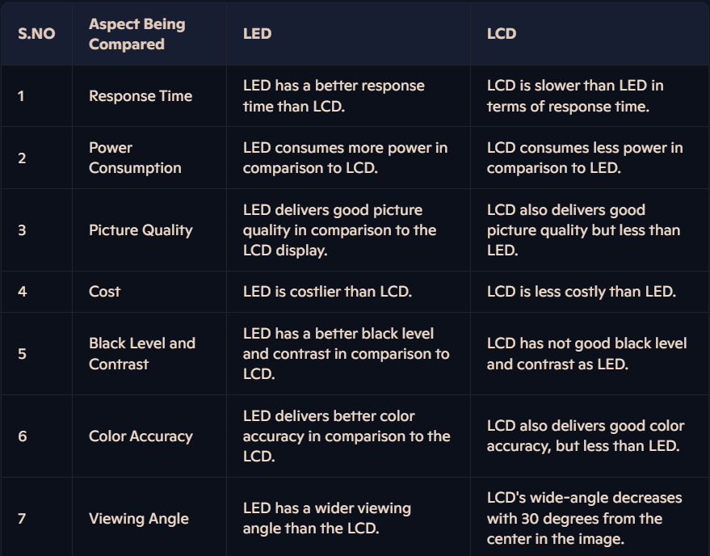

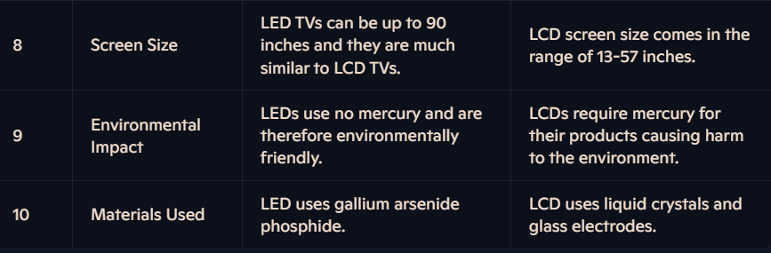

## With a neat diagram explain I2C protocol for data transmission

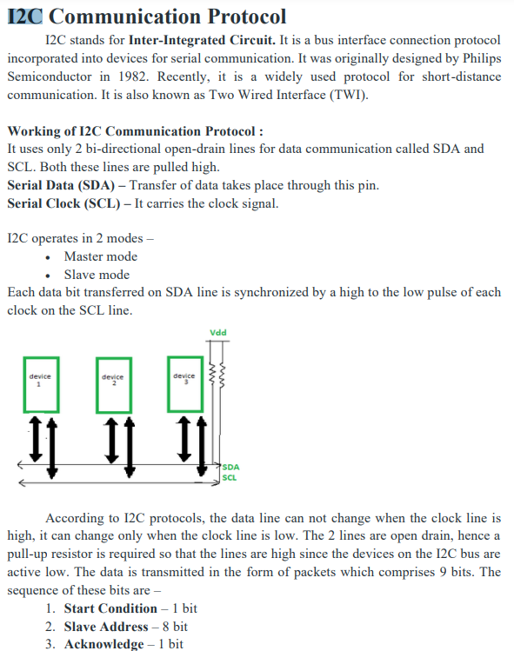

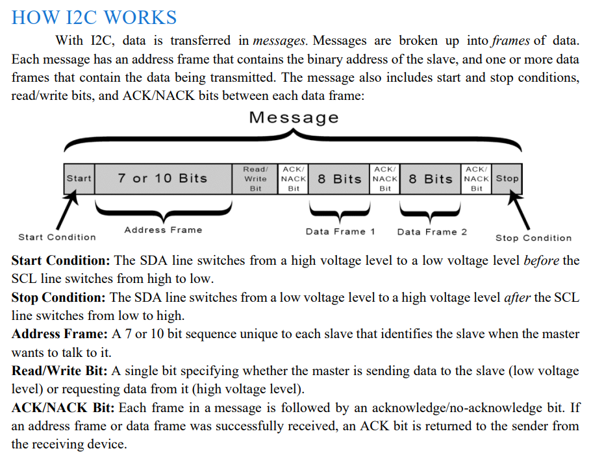

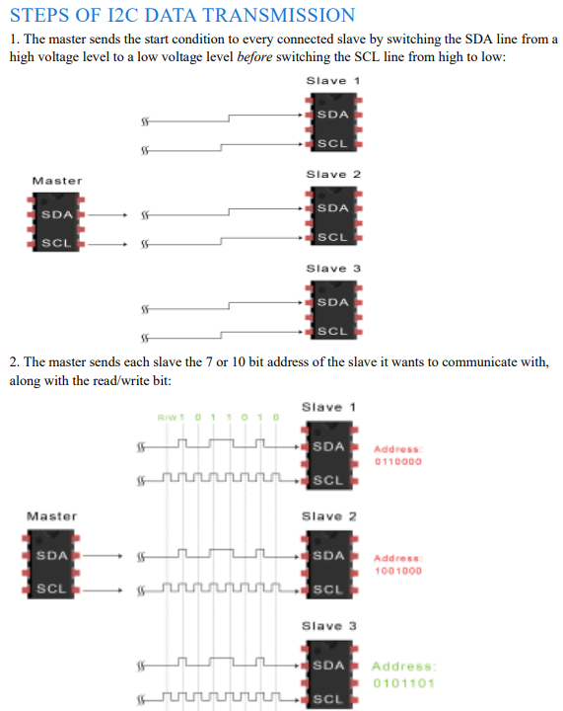

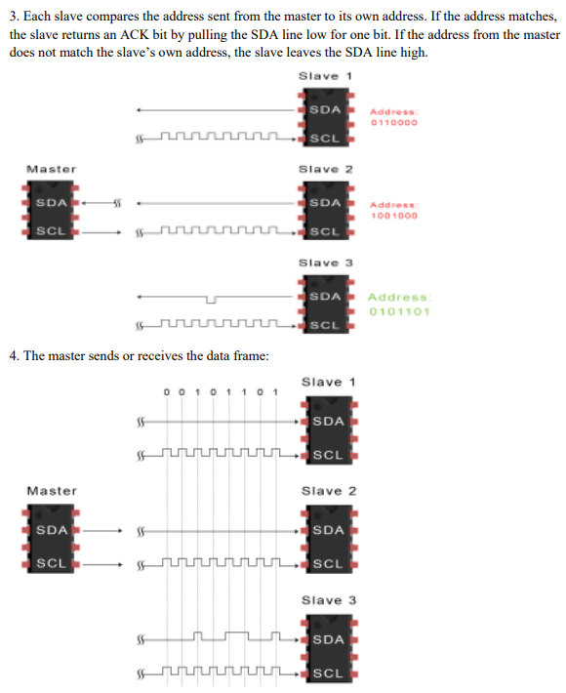

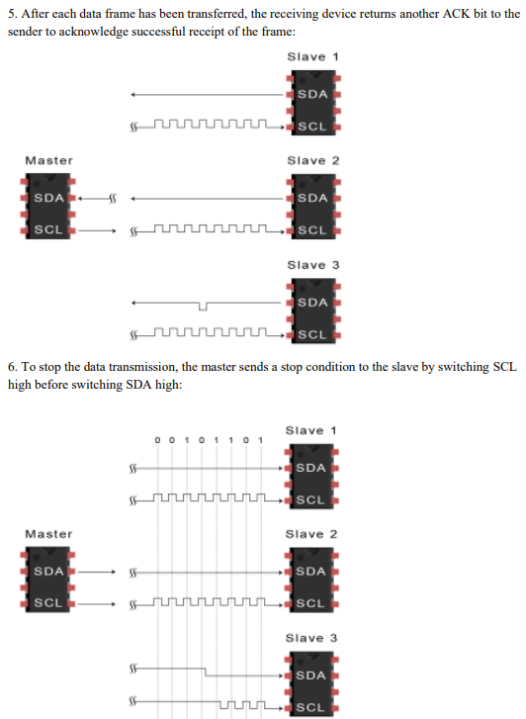

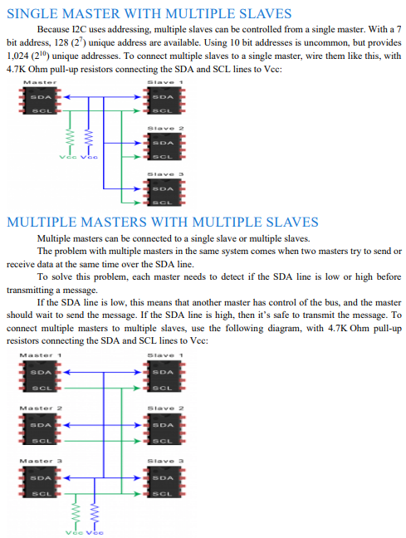

## What are the key features of USB?

Key features of USB

Universal serial bus connections (enabled by USB ports and USB cables) support the following:

1. Hot swapping

Hotswapping is one of the major characteristics of the USB. This functionality enables the removal or replacement of a device without requiring a system restart or interruption. The PC has to be rebooted when installing or uninstalling a device from an older port. Electrostatic discharge (ESD), an unintended electrical current capable of inflicting extensive damage to fragile electronic devices, was initially averted by rebooting. With USB, this is not necessary. Hot

swapping is fault-ruggedized, meaning it can continue functioning despite hardware failure.

2. Direct current transfer

Another aspect of USB is the usage of direct current (DC). Several devices are connected to a DC current through a USB power connection but do not communicate data. Notable examples include USB speakers, small refrigerators, keyboard lamps, and even USB-based device chargers.

3. The use of multiple contact points

All USB connections feature at least four contacts used for power, ground, and two data wires (D

+ and D -). USB 3.0 connectors and above have five contacts. The USB connection is intended to

transmit 5V at a maximum current of 500mA. The USB connection may be inserted in only one

direction. It is feasible to force an incorrect connection. However, this could result in device

damage.

4. Shielding and protection

The USB connection is insulated, providing a metal casing that is not part of the circuit. This

characteristic is crucial for maintaining the signal’s integrity in an electrically “busy” environment.

All USB cables are wrapped in plastic at the connection end to avoid damage to the cable and

electrical connection

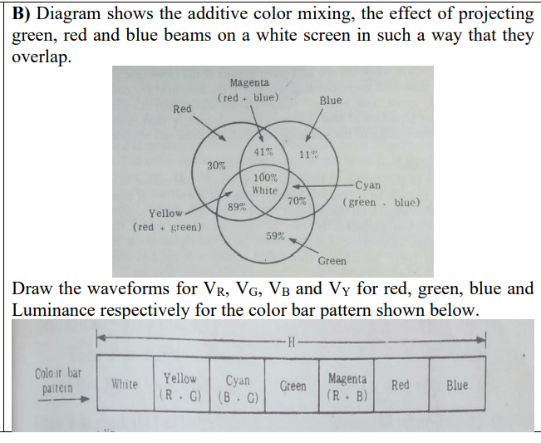

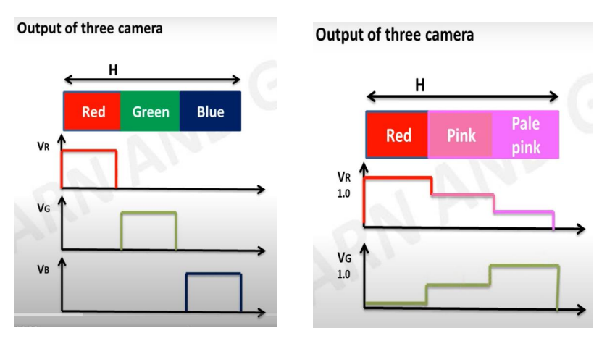

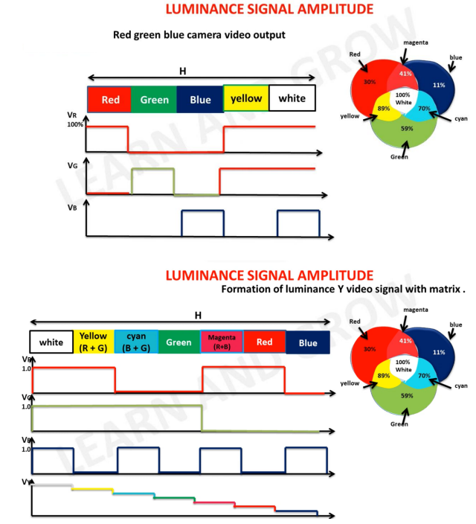

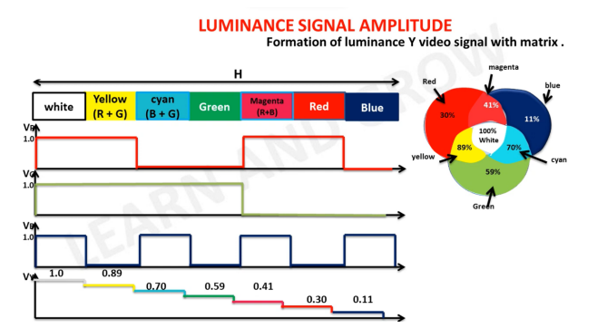

# MSE OCT 2023

## What is thunderbolt? Define the important specifications of thun­derbolt.

USB4 (also known as USB 4.0) is a 2019 standard issued by the USB-IF in version 1.0. The USB4 protocol is built on the Thunderbolt 3 standard, which Intel Corporation submitted to the USB-IF. Its design may dynamically utilize a single high-speed connection with numerous end-device types, executing each transfer according to its data or application type. The first products compatible with USB4 were Intel’s Tiger Lake processors, with more devices appearing around the end of 2020. This type of USB connection is yet to go mainstream.

Thunderbolt is a hardware interface developed by Intel in collaboration with Apple. It combines data, video, audio, and power in a single connection. Thunderbolt technology is known for its high speed and versatility, which makes it a preferred choice for many high-performance devices.

**Important Specifications of Thunderbolt:**

**1. Versions and Speeds:**

* **Thunderbolt 1**: Introduced in 2011, it used the same connector as Mini DisplayPort (mDP), supported data rates of up to 10 Gbps, and could daisy-chain up to six devices.
* **Thunderbolt 2**: Released in 2013, this version essentially doubled the bandwidth to 20 Gbps by combining two 10 Gbps channels into one, allowing for enhanced video capabilities such as 4K video transfer and display.
* **Thunderbolt 3**: Launched in 2015, it adopted the USB-C connector, which is reversible and supports USB compatibility. Thunderbolt 3 offers up to 40 Gbps, which is twice the speed of Thunderbolt 2, supports charging (up to 100 watts), and can connect up to two 4K displays or one 5K display.
* **Thunderbolt 4**: Introduced in 2020, it maintains the same speed as Thunderbolt 3 but improves minimum performance requirements, supports waking from sleep with a peripheral device connected, and requires support for two 4K displays or one 8K display. It also ensures full PCIe 3.0 x4 speeds for storage speeds up to 3,000 MB/s.

**2. Power Delivery:**

* Thunderbolt 3 and 4 can deliver up to 100 watts of power, which means capable of charging laptops and other devices through the same connection used for data and video.

**3. Connectivity and Compatibility:**

* **Daisy-Chaining**: Thunderbolt allows multiple devices to be connected in a series through a single port, with support for up to six devices daisy-chained together.
* **USB Compatibility**: Starting with Thunderbolt 3, the interface includes support for USB, meaning that devices with a USB-C port can also function on a Thunderbolt 3 port, but not all USB-C ports can use Thunderbolt features.

**4. Display Support:**

* Thunderbolt 3 and 4 support dual 4K displays or a single 5K display, making it ideal for high-resolution workflows in video production and professional photography.

**5. Security Features:**

* **Direct Memory Access (DMA) Protection**: Thunderbolt 4 includes mandatory DMA protection which secures devices against potential Thunderspy vulnerabilities, where attackers could previously manipulate Thunderbolt connections to access a computer’s data.

**6. Cable Length:**

* Passive cables can be up to 2 meters long with Thunderbolt 4, while active cables that include transceivers and amplifiers for maintaining signal integrity can be much longer.

## In the early days of television, what type of screen technology was commonly used before the advent of LCD and LED displays? Compare the early days of television screen technology with LCD and LED displays.

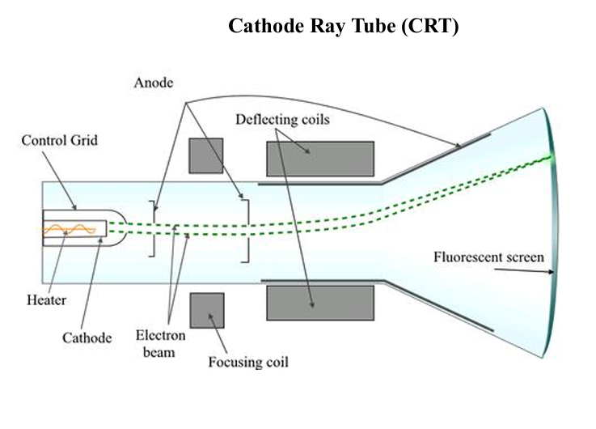

In the early days of television, the technology that dominated the industry was the cathode-ray tube (CRT). This technology was used in the first television sets and remained the standard until the late 20th and early 21st centuries when flat-panel technologies such as LCD and LED started to gain popularity.

**Cathode-Ray Tube (CRT) Technology:**

**How CRT Works:**

* A CRT display works by firing a beam of electrons through an electron gun. This beam is directed by magnetic deflection onto a phosphorescent screen. When the electrons strike the phosphor-coated screen, they light up, producing images.
* CRT televisions support analog signals and are known for their capability to display smoother motion due to their high refresh rates.

**Characteristics of CRT:**

* **Bulk and Weight**: CRTs are bulky and heavy due to the vacuum tube technology and the large amount of glass used.
* **Energy Consumption**: They generally consume more power compared to modern displays.
* **Viewing Angles**: CRTs typically have excellent viewing angles.
* **Color and Contrast**: They are known for having good color depth and contrast ratios.

**Transition to LCD and LED Displays:**

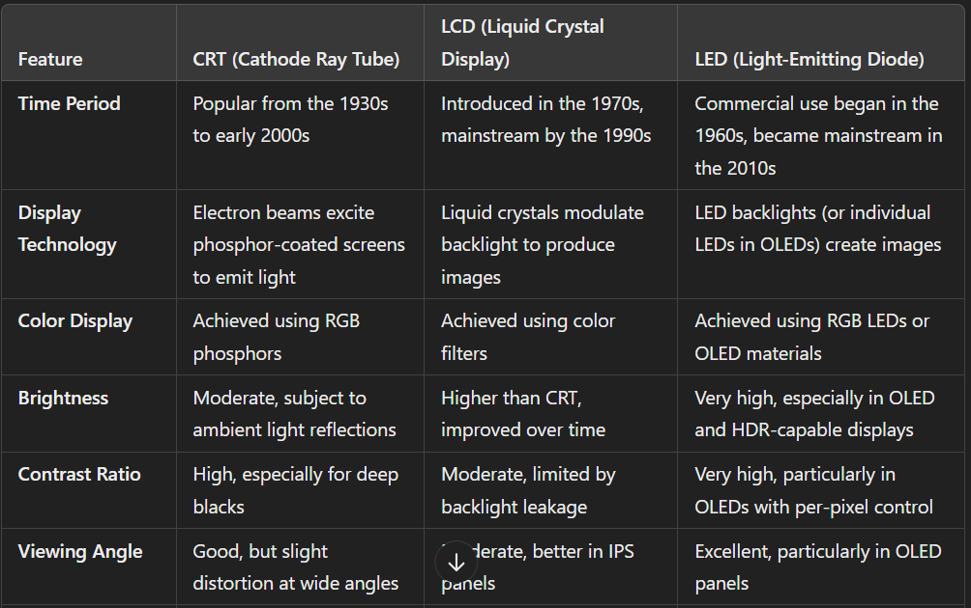

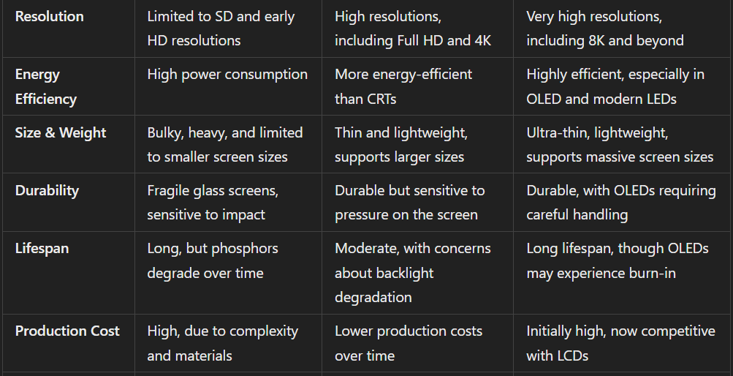

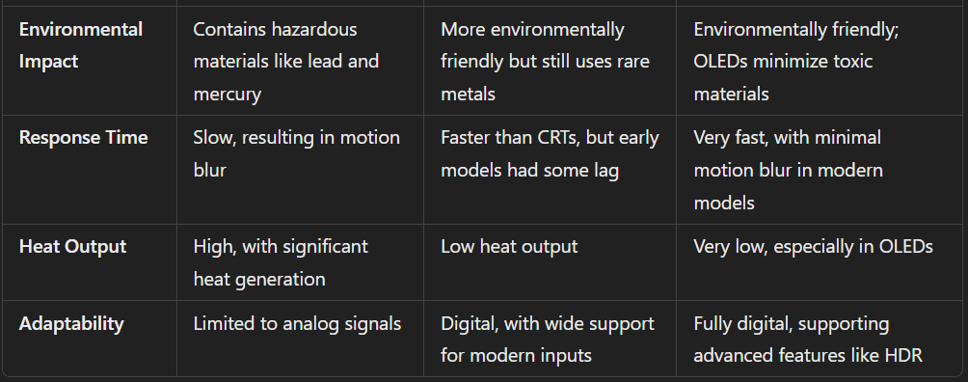

## Explain the purpose of “Shimming” used in MRI machine? Explain the concept of gyromagnetic ratio used in MRI (Magnetic Resonance Imaging) machines.

**1. Purpose of Shimming in MRI Machines**

Shimming in an MRI machine refers to the process of optimizing the homogeneity of the magnetic field within the scanner's bore. This is critical for ensuring high-quality imaging. Here’s a detailed breakdown:

* **Ensures Uniform Magnetic Field:**
  + The primary magnetic field (B₀) generated by the MRI system is not perfectly uniform. Shimming is used to correct small variations to achieve a homogeneous field.
* **Improves Image Quality:**
  + Homogeneous magnetic fields ensure that the Larmor frequency (the precession frequency of hydrogen nuclei) is uniform throughout the scanning volume, reducing image distortions and artifacts.
* **Types of Shimming:**
  + **Passive Shimming:**
    - Adjustments are made using fixed ferromagnetic materials placed strategically inside the scanner during installation.
  + **Active Shimming:**
    - Electromagnetic coils are used to dynamically adjust the magnetic field, allowing corrections during scans.
* **Compensates for Patient-Induced Variations:**
  + The presence of a patient in the scanner may cause distortions in the magnetic field. Active shimming helps in real-time corrections.
* **Applications:**
  + Vital for functional MRI (fMRI) and spectroscopy studies, where precise frequency alignment is critical for detecting subtle changes in tissue properties.

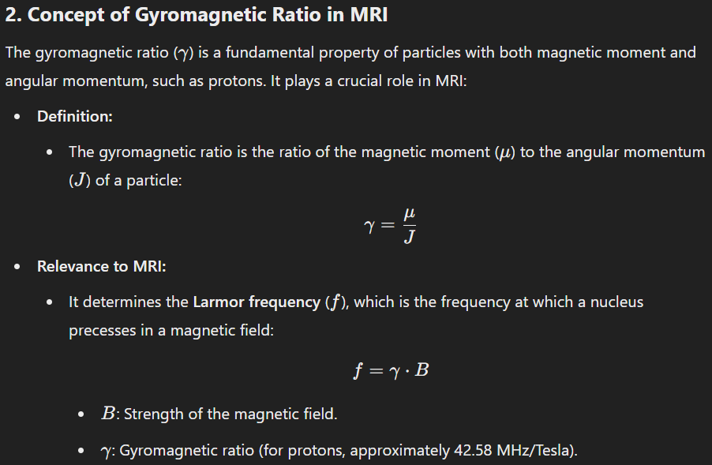

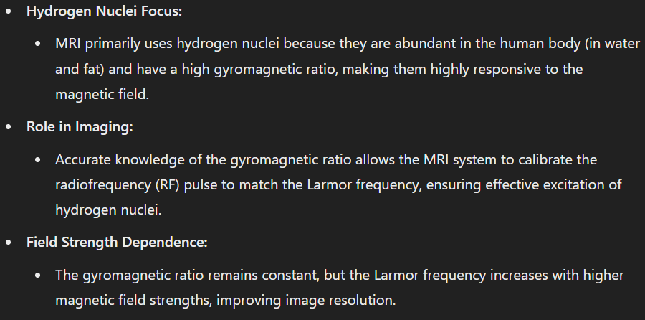

## State at least eight domains in the real-world applications where haptic technology is not only innovative but beneficial also. How?

Haptic technology, which simulates the sense of touch through vibrations, forces, and motions applied to the user, has seen significant advancements and diverse applications across various domains. Here are eight real-world domains where haptic technology is not only innovative but also offers substantial benefits:

**1. Healthcare and Rehabilitation**

* **Application**: Haptic feedback is used in surgical training simulators, allowing medical students and professionals to experience realistic tactile sensations of various medical procedures without the risk.
* **Benefit**: Enhances training effectiveness by providing realistic, hands-on experience without the need for live patients, reducing risk and improving surgical precision.

**2. Virtual and Augmented Reality**

* **Application**: In VR and AR environments, haptic feedback is used to enhance the immersive experience by providing tactile feedback that matches the visual and auditory inputs.
* **Benefit**: Increases immersion and realism, which is essential for applications like virtual training, gaming, and simulations.

**3. Automotive**

* **Application**: Haptic feedback is integrated into vehicle systems to provide alerts and warnings through the steering wheel or seats (like vibrations when the vehicle drifts out of a lane).
* **Benefit**: Improves driver awareness and reaction times, enhancing safety by reducing the likelihood of accidents due to inattention.

**4. Teleoperation and Robotics**

* **Application**: Haptic technology allows operators to control robots or drones and receive tactile feedback as if they were physically present at the location.
* **Benefit**: Enables precise control of robotic systems in hazardous or inaccessible environments, improving safety and efficiency in operations such as underwater exploration or bomb disposal.

**5. Consumer Electronics**

* **Application**: Smartphones and gaming controllers use haptic feedback to provide users with physical responses to touch inputs or game actions.
* **Benefit**: Enhances user experience by making interactions more engaging and intuitive, which can improve usability and satisfaction.

**6. Education and Training**

* **Application**: Educational tools and devices that use haptic feedback can simulate various physical phenomena, allowing students to "feel" the effects in a controlled setting.
* **Benefit**: Enhances learning by engaging multiple senses, which can help in understanding complex concepts, particularly in subjects like physics or engineering.

**7. Assistive Technology**

* **Application**: Haptic feedback is used in devices for individuals with visual or auditory impairments, such as vibrating alert systems or navigational aids.
* **Benefit**: Increases independence and mobility for disabled persons by providing tactile cues that replace or augment diminished senses.

**8. Sports and Fitness**

* **Application**: Wearable fitness devices utilize haptic alerts to guide users through workouts or to notify them about their performance and heart rate levels.
* **Benefit**: Enhances training effectiveness by providing real-time, tactile feedback that helps users optimize their workouts and avoid injury.

## State key features and components of Wacom technology used in stylus pens.

Wacom technology, particularly renowned for its use in stylus pens and digital drawing tablets, represents a significant advancement in digital art and precision input devices. Here are the key features and components that define Wacom's stylus technology:

**Key Features of Wacom Stylus Technology:**

1. **Pressure Sensitivity**:
   * Wacom styluses are known for their high levels of pressure sensitivity, often ranging from 2048 to over 8000 levels of pressure detection. This allows artists to control the thickness, transparency, and texture of lines based on the pressure applied, mimicking traditional drawing tools.
2. **Tilt Recognition**:
   * Many Wacom styluses can detect the angle at which the pen is held. This feature is crucial for simulating natural drawing techniques, such as shading with the side of a pencil.
3. **No Battery Required (EMR Technology)**:
   * Wacom's patented Electromagnetic Resonance (EMR) technology powers the stylus without the need for a battery. The drawing surface generates an electromagnetic field that interacts with the coil inside the pen, providing power and capturing the movement and pressure information from the stylus.
4. **High Precision and Accuracy**:
   * Wacom styluses are designed for pinpoint accuracy, with minimal parallax and no jitter, making them ideal for detailed artwork and professional design tasks.
5. **Programmable Buttons**:
   * Styluses often come with side switches and an eraser tip that can be programmed for specific actions like right-click, double-click, or switching between drawing tools, enhancing workflow efficiency.
6. **Hover Distance**:
   * Wacom pens can typically be detected by the tablet from a few millimeters away, allowing users to hover the stylus above the surface to move the cursor without making contact. This feature aids in precise cursor placement and operation.
7. **Compatibility with Various Nibs**:
   * Wacom pens can be equipped with different types of nibs, such as felt, flex, and stroke nibs, allowing users to customize the feel and feedback of their stylus to suit their drawing style and preference.

**Components of Wacom Stylus Pens:**

1. **Resonance Circuit**:
   * The core of the pen contains a resonance circuit including a coil and a capacitor that resonates with the electromagnetic field provided by the tablet, allowing it to operate wirelessly.
2. **Pressure Sensor**:
   * Located near the tip of the pen, the pressure sensor detects the amount of pressure being applied and adjusts the output accordingly.
3. **Control Board**:
   * A small control board inside the stylus interprets the signals from the pressure sensor and buttons, sending this information back to the tablet.
4. **Tip and Nib**:
   * The tip of the pen where the nib is inserted is the main point of contact with the tablet surface. The nib can be replaced depending on the user’s preference for different feels (e.g., harder or softer).
5. **Side Switches**:
   * One or more customizable buttons located on the side of the stylus act like keyboard shortcuts, improving workflow and functionality.
6. **Eraser**:
   * Some models include an eraser on the opposite end of the pen, functioning just like a pencil eraser, which can be used in software that supports this feature.

Wacom technology is specifically tailored to meet the needs of graphic artists, designers, and hobbyists who require precision and versatility in their digital drawing tools. The combination of these advanced features and components makes Wacom styluses a top choice in the world of digital art and design.

# ESE MAY 2024

## You are a manufacturer developing a revolutionary new augmented reality (AR) device. Analyze the advantages and disadvantages of each display technology (OLED, alphanumeric, LED, LCD) and explain which one you would choose for your AR glasses. Justify your decision based on factors like resolution, power consumption, and suitability for AR applications.

1. OLED (Organic Light-Emitting Diode):

Advantages:

* Excellent contrast ratio and deep blacks (pixels can turn completely off)
* Wide colour gamut and vibrant colours
* Fast response time, reducing motion blur
* Flexible and can be made very thin
* Wide viewing angles
* No backlight required, potentially saving power

Disadvantages:

* Higher production costs
* Potential for burn-in with static images
* Shorter lifespan compared to some other technologies
* Lower brightness compared to LED displays

1. Alphanumeric:

Advantages:

* Simple and cost-effective
* Low power consumption
* High durability

Disadvantages:

* Very limited display capabilities (only text and basic symbols)
* Not suitable for complex graphics or images
* Low resolution

1. LED (Light-Emitting Diode):

Advantages:

* High brightness
* Good energy efficiency
* Long lifespan
* Durable and resistant to shock

Disadvantages:

* Limited resolution compared to OLED and LCD
* Less suitable for displaying fine details
* Can be bulky, especially for micro-LED implementations

1. LCD (Liquid Crystal Display):

Advantages:

* Well-established technology with mature manufacturing processes
* Good resolution capabilities
* Relatively low cost
* No burn-in issues

Disadvantages:

* Requires backlight, increasing power consumption
* Lower contrast ratio compared to OLED
* Slower response times, potentially causing motion blur
* Limited viewing angles

For AR glasses, I would choose OLED technology. Here's why:

1. Resolution: OLED can provide very high pixel densities, which is crucial for AR applications where fine details and text need to be overlaid on the real world. The ability to display sharp, clear images is essential for a seamless AR experience.
2. Contrast and Color: The excellent contrast ratio and wide color gamut of OLED displays will help AR elements stand out against real-world backgrounds, enhancing the overall visual experience.
3. Response Time: Fast response times are critical in AR to prevent lag between head movements and display updates. OLED's superior performance in this area will contribute to a more immersive and comfortable user experience.
4. Form Factor: OLED's flexibility and thinness are significant advantages for AR glasses, where minimizing bulk and weight is crucial for user comfort and aesthetic appeal.
5. Power Efficiency: While OLED may not be the most power-efficient in all scenarios, its ability to selectively illuminate only necessary pixels can lead to power savings in many AR use cases where only parts of the display are active.
6. Viewing Angles: Wide viewing angles are important for AR glasses to maintain image quality as the user's eyes move, which OLED handles very well.

The main drawbacks of OLED for this application are higher costs and potential burn-in. However, the benefits outweigh these concerns:

* Costs are likely to decrease as OLED technology matures and production scales up.
* Burn-in is less of an issue in AR applications where images are typically dynamic and changing, unlike static UI elements in smartphones.

While LCD could be a viable alternative due to its lower cost and lack of burn-in issues, its need for backlighting and inferior contrast make it less suitable for the transparent displays often used in AR glasses.

LED technology, particularly micro-LED, shows promise for future AR applications but is currently less mature and may be more challenging to implement in a compact form factor.

Alphanumeric displays are clearly unsuitable due to their limited capabilities.

## Illustrate the trade-offs between different touch panel technologies like resistive and capacitive touchscreens. Consider factors like cost, durability, accuracy, multi-touch capabilities, and suitability for different applications. When might one technology be preferable over the other? Draw suitable diagram.

**Touch Panel Technologies: Resistive vs. Capacitive Touchscreens**

The two primary types of touchscreen technologies prevalent in the market are resistive and capacitive touchscreens. Each has its advantages and disadvantages, which influence their suitability for different applications. Below is an analysis of these technologies based on cost, durability, accuracy, multi-touch capabilities, and general suitability for various uses.

**1. Resistive Touchscreens**

**Technology**: Resistive touchscreens consist of two flexible layers coated with a conductive material, separated by an air gap or spacers. When touched, the two layers make contact at that point, completing a circuit.

**Advantages**:

* **Cost**: Generally cheaper to manufacture than capacitive screens.
* **Durability**: Quite durable and resistant to water and dust.
* **Input Flexibility**: Can be operated with any stylus, glove, or even a finger, making it versatile for various environments.

**Disadvantages**:

* **Accuracy**: Less accurate than capacitive screens, especially around the edges.
* **Multi-Touch**: Basic resistive touchscreens do not support multi-touch, which limits their functionality for modern applications.
* **Clarity**: The multiple layers can reduce the clarity of the display.

**Suitability**: Best for environments where gloves are worn (industrial settings) and cost is a critical factor. Ideal for uses where precision touch control is less crucial, such as some consumer electronics, point-of-sale systems, and industrial controls.

**2. Capacitive Touchscreens**

**Technology**: Capacitive touchscreens are coated with a conductive material and work by sensing the electrical properties of the human body. Touching the screen alters the device’s electrostatic field at the touch point.

**Advantages**:

* **Accuracy**: Offers high precision and responsiveness, especially in smartphones and tablets.
* **Multi-Touch**: Supports multi-touch gestures like pinching and zooming, which are integral to modern touchscreen functionality.
* **Durability**: High durability and typically offers better clarity as it requires only one main layer that interacts directly with touch.

**Disadvantages**:

* **Cost**: More expensive to manufacture than resistive touchscreens.
* **Input Limitation**: Only responds to finger touches or specialized capacitive styluses, not regular styluses, gloves, or other non-conductive materials.
* **Environmental Sensitivity**: Performance can be affected in environments with high humidity or where the user is wearing gloves.

**Suitability**: Ideal for consumer electronics (smartphones, tablets), multi-touch applications, and environments where high clarity and sensitivity are required.

**Choosing Between Resistive and Capacitive Touchscreens**

* **Cost-Sensitive Applications**: Choose resistive touchscreens for lower costs.
* **High-End Consumer Devices**: Opt for capacitive touchscreens for their multi-touch capabilities and accuracy.
* **Industrial Applications**: Resistive touchscreens are often better because they can handle touches from any object and are less affected by environmental factors like dust and water.
* **Outdoor Environments**: Capacitive screens are generally more visible in direct sunlight compared to resistive screens.

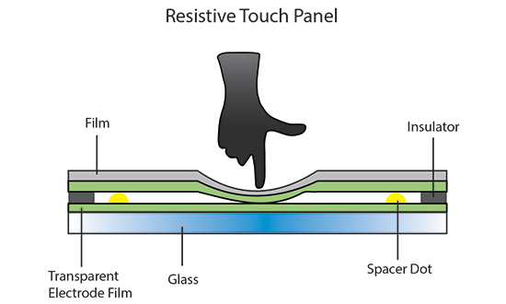

Capacitive Touchscreen

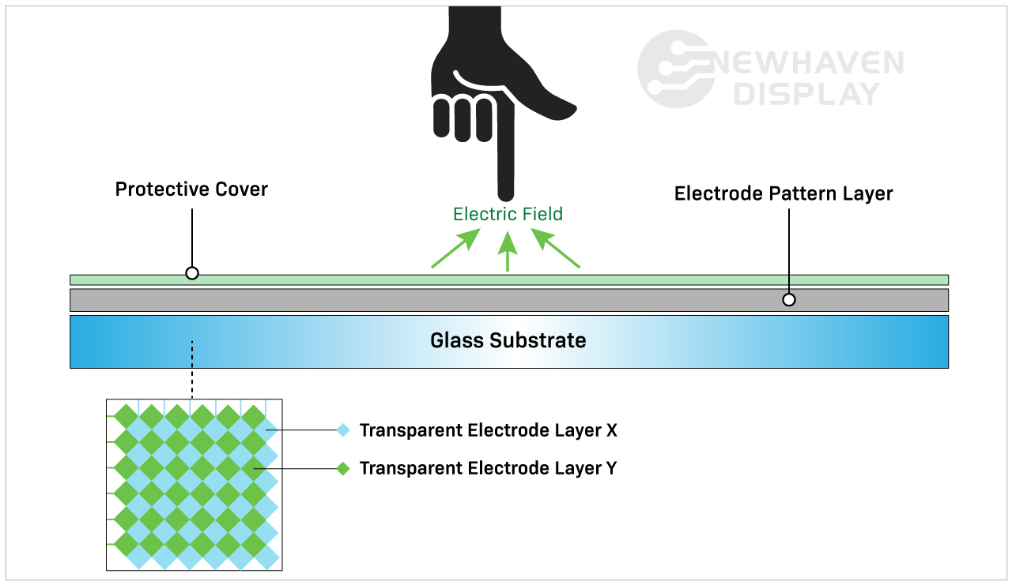

## A master device (microcontroller) needs to send data to a specific slave device (sensor) on an I2C bus. Illustrate the essential steps involved in this I2C data transmission, focusing on the key signals and their functionalities.

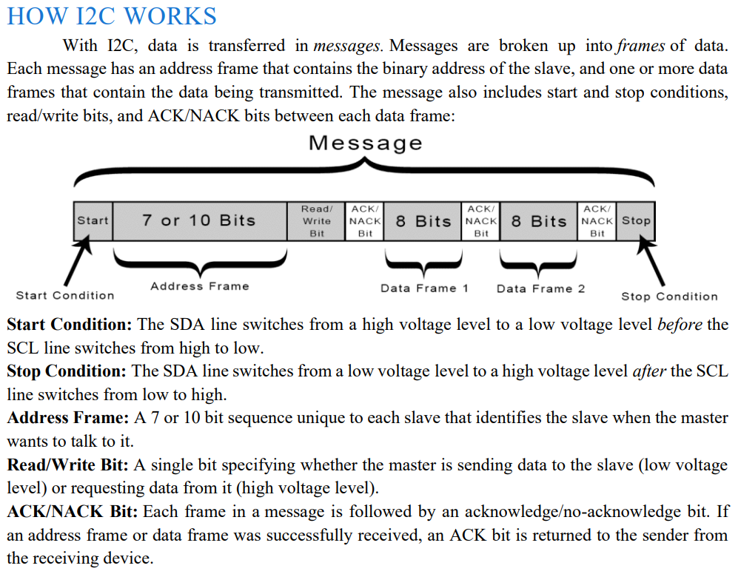

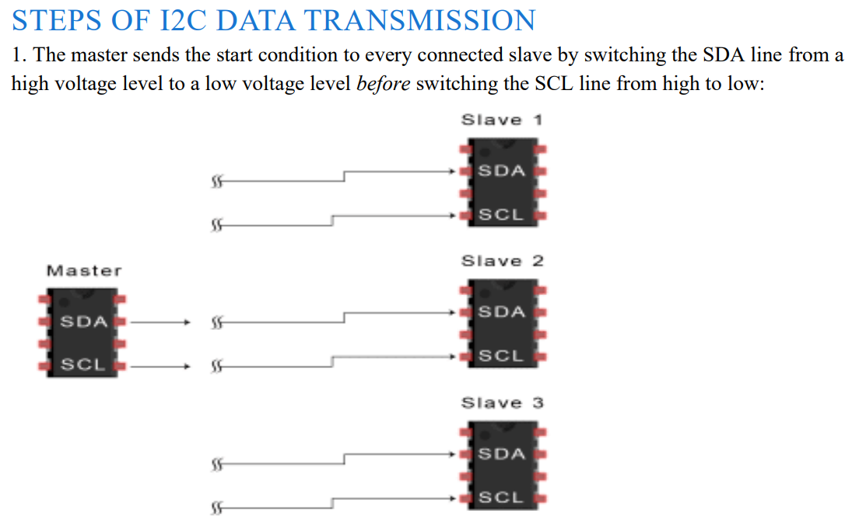

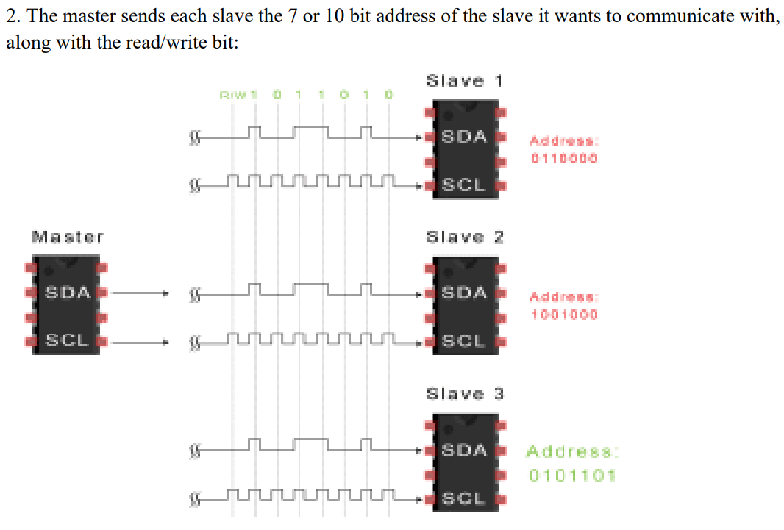

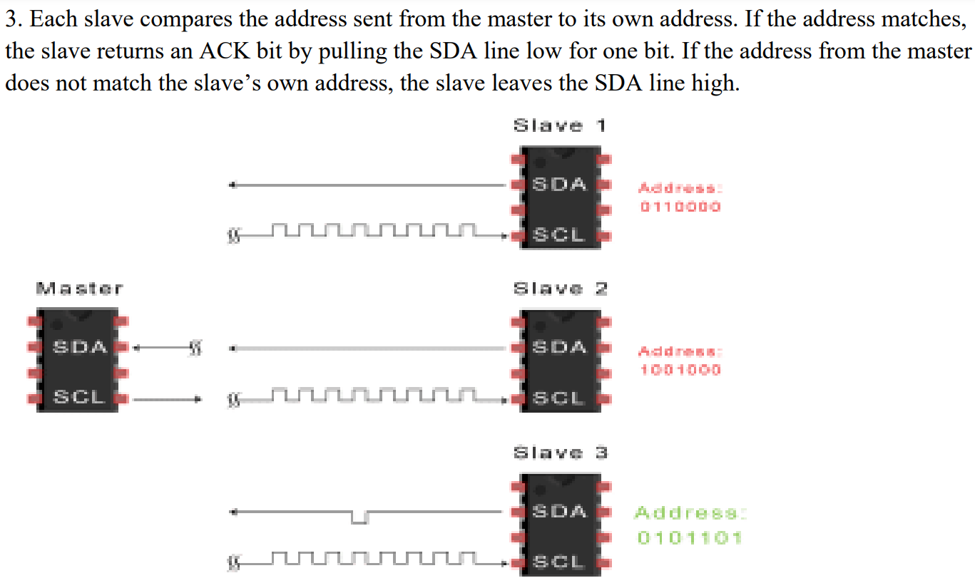

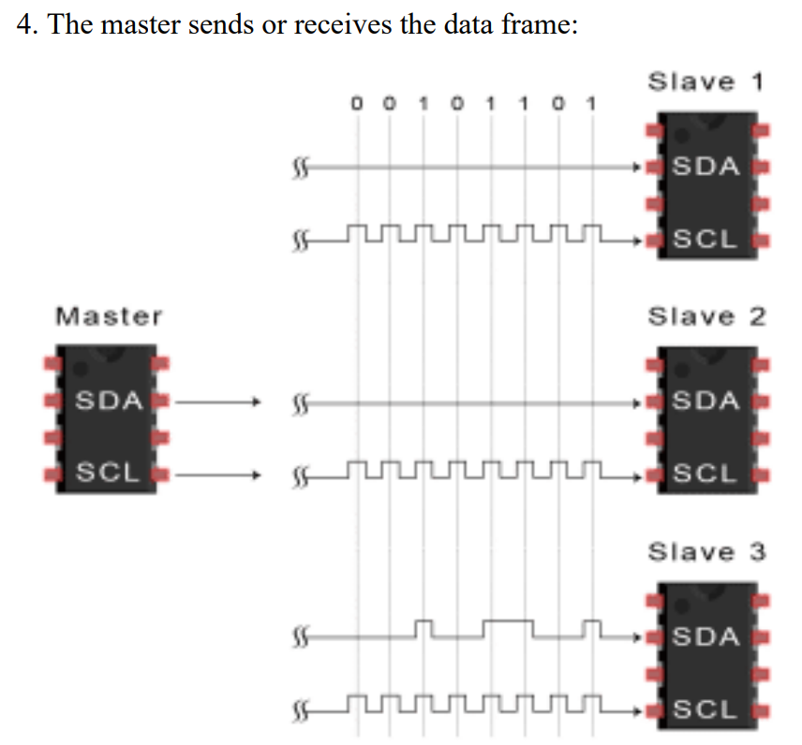

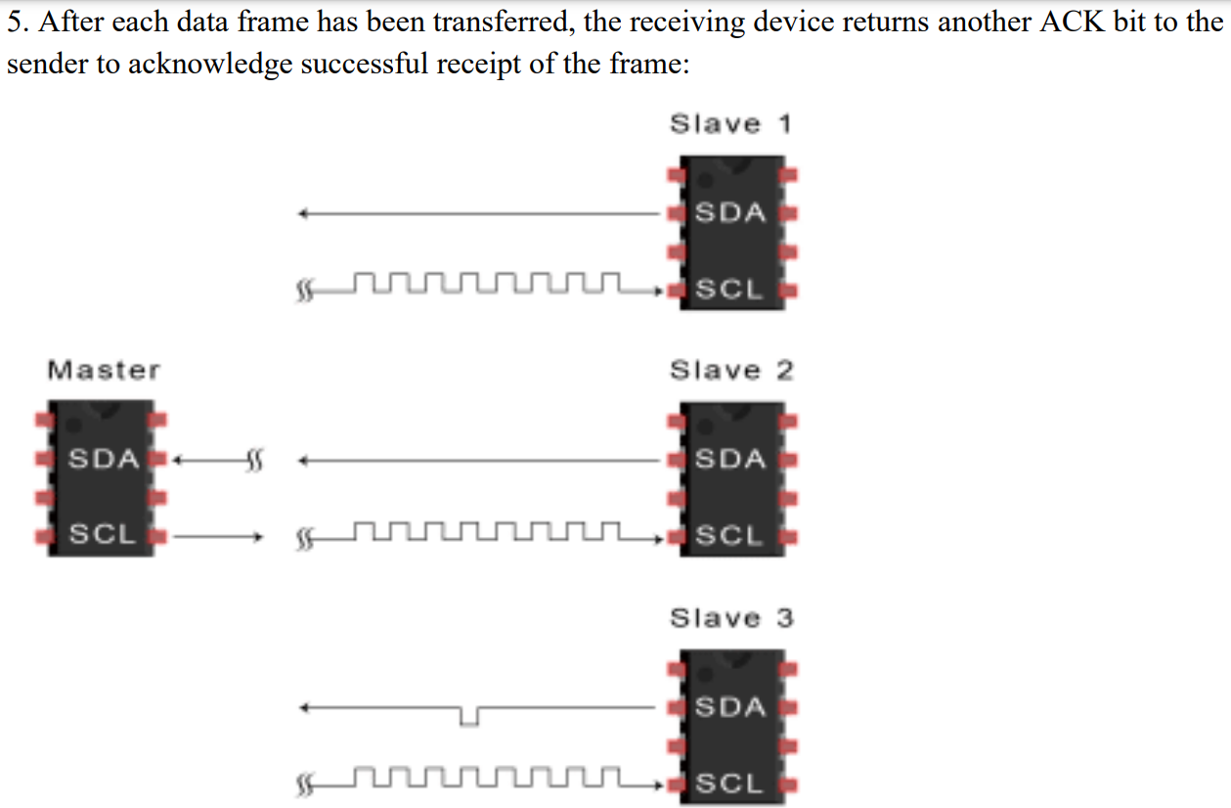

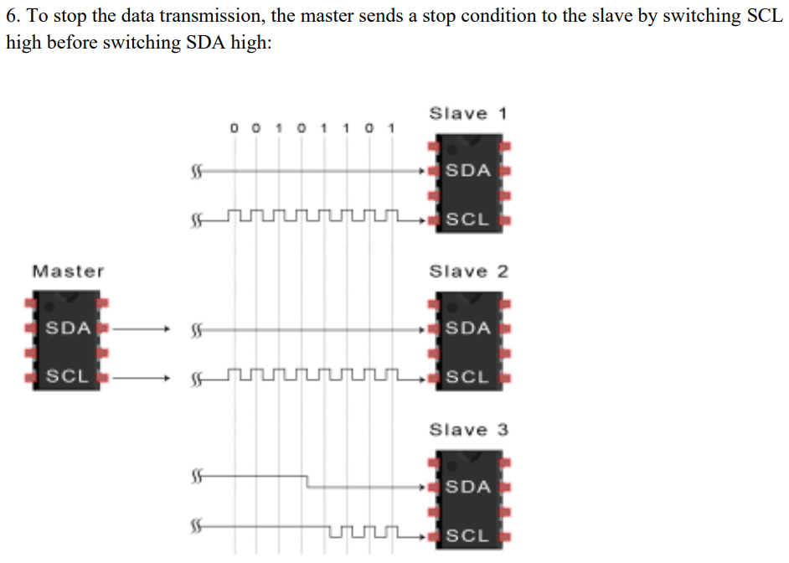

## Explain the following aspects of a color television camera system:

## Briefly describe the role of a color circle in understanding color reproduction in a camera system. How does the camera differentiate between various colors?

**Aspects of a Color Television Camera System**

**1. Role of a Color Circle in Understanding Color Reproduction**

The color circle (or color wheel) is an essential tool for understanding how colors are reproduced in a color television camera system. Its role includes:

* **Representation of Primary and Complementary Colors:**
  + The color circle organizes colors in a circular arrangement, showing relationships between primary colors (red, green, blue) and their complementary colors (cyan, magenta, yellow).
* **Additive Color Mixing:**
  + A color circle demonstrates how combining different proportions of red, green, and blue (RGB) light can produce all visible colors. This is fundamental to the RGB-based operation of color cameras.
* **Visualizing Hue, Saturation, and Intensity:**
  + The position on the circle indicates the hue (type of color), while the distance from the center reflects the saturation (vividness). The intensity (brightness) is adjusted independently.
* **Understanding Color Correction:**
  + Helps in aligning the camera’s sensor outputs to accurately reproduce colors by adjusting RGB signal strengths.
* **Applications in Signal Encoding:**
  + The circle aids in encoding color signals (e.g., NTSC, PAL systems) by defining relationships between luminance (brightness) and chrominance (color information).

**2. How the Camera Differentiates Between Various Colors**

A color television camera system differentiates colors by analyzing the light reflected or emitted from objects and processing it through its imaging system. Key points include:

* **Splitting of Light:**
  + Incoming light is passed through an optical system (lens and beam splitter) that separates it into its primary color components: red, green, and blue (RGB).
* **Use of Color Filters:**
  + Filters ensure that each sensor (or section of the sensor) receives only one colour component, enabling precise color separation.
* **RGB Sensors:**
  + The separated light components are detected by RGB-sensitive sensors (e.g., CCD or CMOS sensors) that convert light into electrical signals proportional to the intensity of each color.
* **Signal Processing:**
  + The camera processes the signals from the RGB channels to calculate:
    - **Luminance (Y):** Represents the brightness, derived from a weighted sum of RGB values.
    - **Chrominance (U and V or Cb and Cr):** Encodes colour information as differences from the luminance.
* **Color Encoding:**
  + The differentiated signals are encoded into a standard format (e.g., YUV, YIQ, or RGB) for further transmission or display.
* **Color Matching and Reproduction:**
  + The camera system uses internal algorithms to match the captured colors to real-world colors, compensating for sensor and environmental variations.

## Most color camera systems use a three-sensor approach to capture red, green, and blue (RGB) color information. However, they ultimately transmit a luminance (Y) signal and two chrominance (C) signals. Explain the concept of the Y signal using the formula:

## Y = 0.299R + 0.587G + 0.114B

## What do the coefficients (0.299, 0.587, 0.114) represent?

**1. Concept of the Y Signal**

The **Y signal**, or luminance signal, represents the brightness or intensity of the image and is derived from the red (R), green (G), and blue (B) color components. It is calculated using the formula:

Y=0.299R+0.587G+0.114B

* **Purpose of the Y Signal:**
  + It provides a grayscale representation of the image, which is essential for black-and-white televisions and ensures backward compatibility with older systems.
  + The Y signal carries most of the image's brightness information, which is more critical for human perception than color details.
* **Separation of Color Information:**
  + Along with the Y signal, the remaining color information is transmitted as two chrominance (C) signals. These encode the color differences, typically represented as:
    - **U (or Cb):** Blue minus luminance (B−Y).
    - **V (or Cr):** Red minus luminance (R−Y).
  + This separation reduces the bandwidth required for transmitting color data while maintaining perceptual quality.

**2. Coefficients in the Formula**

The coefficients (0.299, 0.587, 0.114) in the formula have specific meanings and significance:

* **Relative Contribution of RGB to Brightness:**
  + These values represent the human eye's sensitivity to different colors:
    - **Red (R):** 0.299 – Red light contributes significantly to brightness but less than green.
    - **Green (G):** 0.587 – Green light has the highest contribution because the human eye is most sensitive to green wavelengths.
    - **Blue (B):** 0.114 – Blue light contributes the least to brightness because the eye is least sensitive to blue wavelengths.
* **Derived from Perceptual Studies:**
  + The coefficients were determined through experiments and research into human vision, which found that green dominates brightness perception, followed by red and then blue.
* **Ensures Accurate Brightness Representation:**
  + By weighting the RGB components according to human sensitivity, the Y signal accurately reflects perceived brightness.

**3. Why This Approach is Used**

* **Efficient Transmission:**
  + Transmitting Y (luminance) and C (chrominance) signals separately reduces the amount of data required while preserving image quality.
* **Human Perception:**
  + The eye is more sensitive to brightness (luminance) than to fine color details, so focusing on luminance ensures better perceived image quality.
* **Backward Compatibility:**
  + Black-and-white TVs can decode the Y signal to display the image without requiring color information.

## Explain why and draw the amplitude of the Y signal would be different for the following color patterns displayed on the camera sensor.

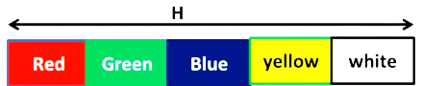

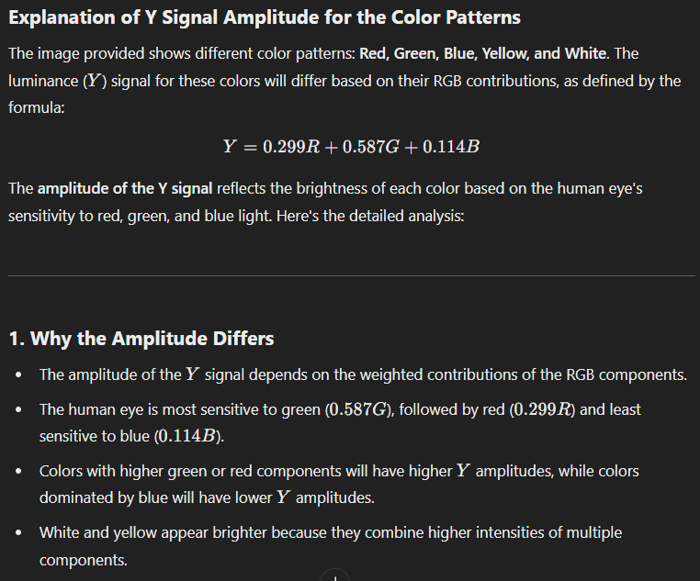

**2. Analysis of Each Color Pattern**

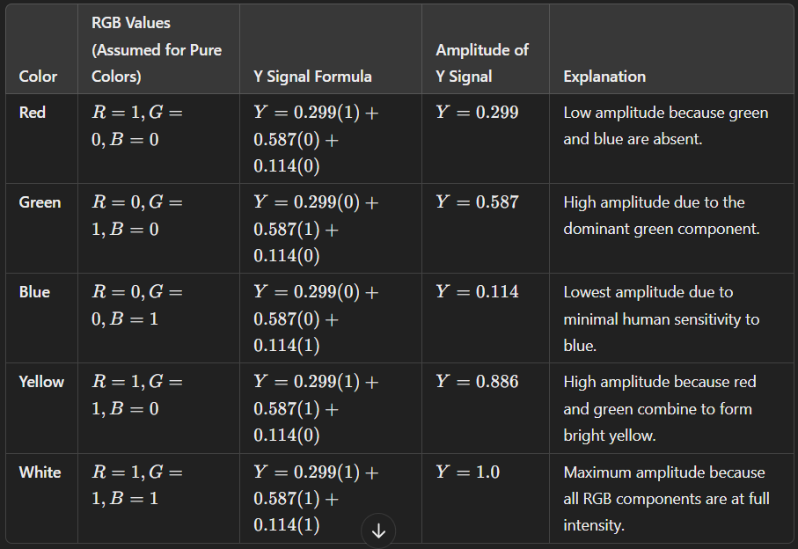

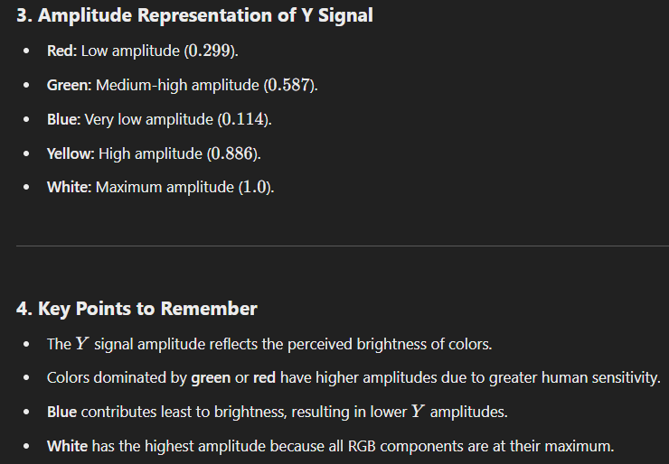

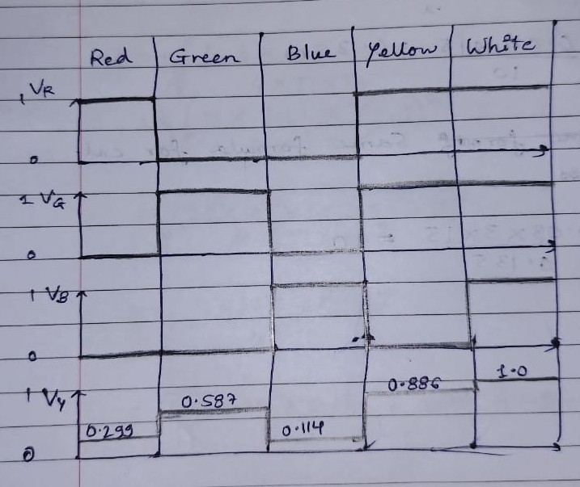

## Compare the key differences between standard definition television (SDTV) and HDTV. Explain how the increased resolution in HDTV contributes to a sharper and more detailed viewing experience. compare some of the common HDTV formats (e.g., 720p, 1080i) and their variations.

**1. Key Differences Between Standard Definition Television (SDTV) and HDTV**

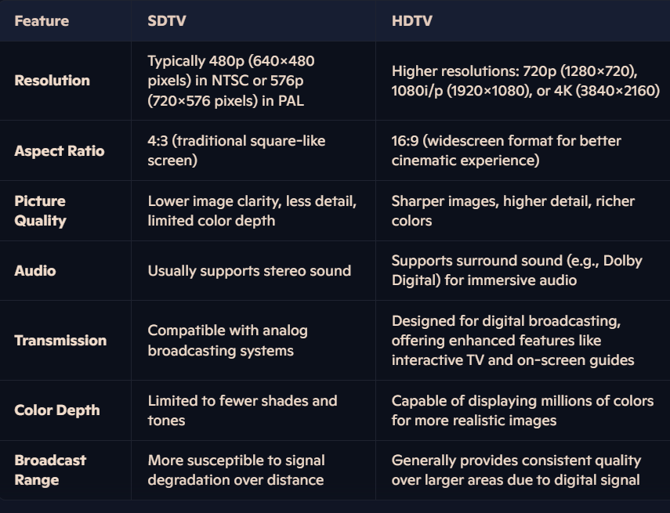

**2. How Increased Resolution in HDTV Contributes to a Sharper and More Detailed Viewing Experience**

* **Higher Pixel Density**:
  + More pixels per unit area provide finer details in images, reducing pixelation.
* **Improved Clarity**:
  + Greater resolution enhances edge sharpness and texture details, making images more lifelike.
* **Enhanced Depth and Color**:
  + Higher resolution allows for better rendering of gradients and colour accuracy.
* **Better for Large Screens**:
  + HDTV maintains image quality on larger displays, whereas SDTV images appear blurry or stretched.

**3. Comparison of Common HDTV Formats**

* **720p (Progressive Scan)**:
  + **Resolution**: 1280x720 pixels.
  + **Features**: Progressive scanning updates the entire frame in one pass, ideal for fast-moving content (e.g., sports).
  + Offers a good balance of resolution and smoothness, suitable for smaller screens or lower budgets
* **1080i (Interlaced Scan)**:
  + **Resolution**: 1920x1080 pixels.
  + **Features**: Interlaced scanning updates alternate lines per frame, suitable for slow-moving visuals (e.g., documentaries).
  + Offers higher resolution than 720p but can have some motion artifacts.
* **1080p (Progressive Scan)**:
  + **Resolution**: 1920x1080 pixels.
  + **Features**: Combines high resolution with progressive scanning for smooth, detailed motion.
  + Provides the highest resolution of the common formats, offering the most detail and sharpness.
* **4K UHD** (Ultra High Definition):
  + **Resolution**: 3840x2160 pixels.
  + **Features**: Four times the resolution of 1080p, offering extreme clarity and detail for modern displays.
  + Viewing Distance: Sit closer to the screen and you'll notice the difference in resolution more.
  + Content Quality: The quality of the source material also affects the final image quality. Even with HDTV, low-quality source material will still look less than ideal.

## In the early days of color television, a major hurdle was ensuring everyone could enjoy the new technology. How did engineers design color TV systems to be compatible with existing black-and-white televisions?

**How Engineers Made Color TV Systems Compatible with Black-and-White TVs**

1. **NTSC Compatibility Standard**:
   * Engineers designed colour TV systems following the **NTSC (National Television Standards Committee)** standard to ensure backward compatibility with black-and-white televisions.
2. **Incorporation of Luminance (Y)**:
   * The color signal was designed to carry a **luminance (Y)** component, representing brightness.
   * This component alone could be displayed by black-and-white TVs, maintaining the original grayscale image.
3. **Addition of Chrominance (C)**:
   * Color information was encoded into **chrominance** signals (U and V components), which represented the hue and saturation of colors.
   * These signals were modulated in a way that black-and-white TVs could ignore them, preventing interference with grayscale images.
4. **Use of Subcarrier Frequency**:
   * The chrominance signal was added to the video signal using a **subcarrier frequency**.
   * This subcarrier frequency was carefully chosen to minimize interference with the black-and-white signal while still being decodable by color televisions.
5. **Compatible Color Transmission**:
   * Black-and-white TVs ignored the chrominance subcarrier and displayed only the luminance signal.
   * Color TVs used both luminance and chrominance signals to reconstruct full-color images.
6. **Bandwidth Management**:
   * Engineers optimized bandwidth allocation to transmit additional color information without requiring major changes to existing broadcasting equipment.
7. **Interleaving Signals**:
   * Chrominance signals were interleaved with the luminance signal, ensuring the color information did not distort the black-and-white image.
8. **Phase Modulation of Color Burst**:
   * A brief reference signal, known as the **color burst**, was transmitted with each line.
   * Color TVs used this signal to decode the phase and amplitude of the chrominance components, allowing accurate color reproduction.
9. **Standardization of Color Encoding**:
   * The use of standardized color encoding methods (e.g., **YUV or YIQ**) ensured seamless integration with existing black-and-white systems while adding color information.

## Explain the basic characteristics of sound signals using appropriate definitions and examples.

## Loudness

## Pitch

## Frequency Response

## Fidility

## Sensitivity of Human ear for Sound

**1. Loudness**

* **Definition:** Loudness, also known as volume, is the subjective perception of the intensity of a sound. It is how loud or soft a sound appears to the listener.
* **Technical Term:** Sound intensity, measured in decibels (dB).
* **Example:** A whisper has low loudness, while a jet engine roar has very high loudness.
* **Impact:** Loudness affects the listener's experience of a sound, influencing its clarity, impact, and enjoyment.

**2. Pitch**

* **Definition:** Pitch is the subjective perception of the frequency of a sound. It describes how high or low a sound appears to be.
* **Technical Term:** Frequency, measured in Hertz (Hz).
* **Example:** A high-pitched whistle has a high frequency, while a low-pitched bass drum has a low frequency.
* **Impact:** Pitch plays a critical role in music and speech, defining the melody, harmony, and tonality of a sound.

**3. Frequency Response**

* **Definition:** Frequency response describes the range of frequencies that a sound reproduction system (like a speaker or microphone) can accurately reproduce.
* **Example:** A high-fidelity speaker with a wide frequency response can reproduce both low bass frequencies and high treble frequencies.
* **Impact:** A wide frequency response is important for a balanced and faithful reproduction of sound, while a narrow frequency response can result in a distorted or incomplete sound.

**4. Fidelity**

* **Definition:** Fidelity refers to the faithfulness of a sound reproduction system to the original sound signal. It describes how accurately a system replicates the original sound.
* **Example:** A high-fidelity audio system with minimal distortion and a wide frequency response will reproduce a sound signal with high fidelity.
* **Impact:** High fidelity is crucial for preserving the nuances and details of the original sound, resulting in a more enjoyable and authentic listening experience.

**5. Sensitivity of the Human Ear to Sound**

* **Definition:** The human ear is most sensitive to frequencies in the range of 2-5kHz. This means we perceive sounds in this range as louder, even if they are of equal intensity to sounds outside this range.
* **Impact:** This sensitivity explains why voices and many musical instruments fall within this range. Audio engineers often emphasize frequencies in this range to make recordings sound more pleasing to the listener.

## Using a labeled block diagram of a blood pressure monitor, explain the function of each major block involved in the measurement process.

## Also Mention any additional features the block diagram might represent, such as memory for storing readings or a communication interface for data transfer.

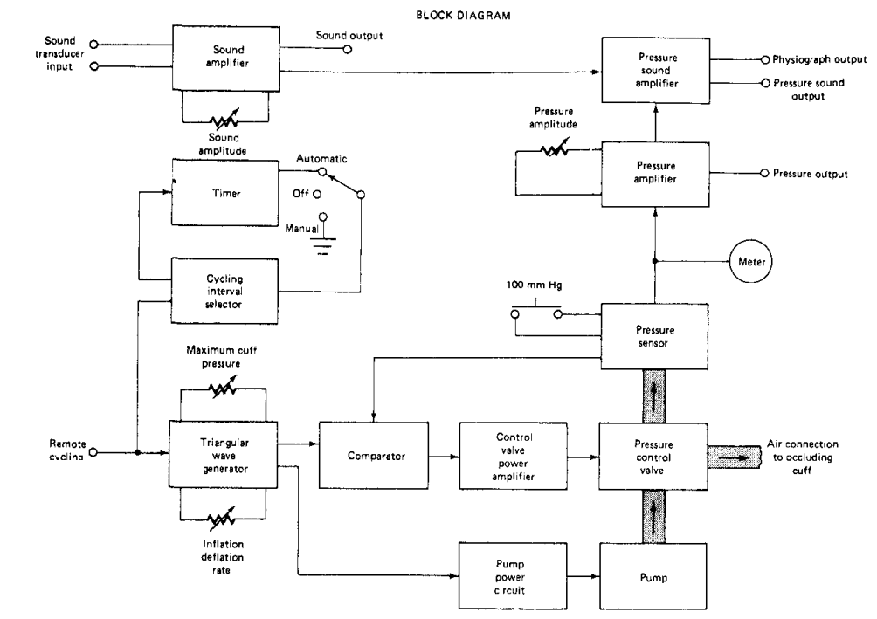

Sound Transducer: This is the component that converts the physical pressure waves (sound) from the patient's blood flow into an electrical signal. It acts as the input, converting the physical phenomenon into an electrical representation that the rest of the system can process.

Sound Amplifier: The electrical signal from the sound transducer is likely very weak, so the sound amplifier boosts the amplitude of this signal to a level that can be more easily processed by the subsequent components.

Sound Amplitude: This block likely measures the strength or volume of the sound signal, which corresponds to the pressure variations in the patient's blood flow. Monitoring the amplitude of the sound waves provides information about the blood pressure.

Automatic Off/Manual: This block allows the user to control whether the blood pressure measurement is done automatically on a set schedule, or manually when the user chooses to take a reading.

Timer: If the automatic mode is selected, the timer is responsible for triggering the blood pressure measurement at the appropriate intervals.

Cycling Interval Selector: This block allows the user to set the time interval between automatic blood pressure measurements.

Maximum Cuff Pressure: This sets the upper limit for the pressure applied by the blood pressure cuff, to ensure the patient's safety.

Remote Cycling Generator: This generates the electrical signals that control the inflation and deflation of the blood pressure cuff around the patient's arm.

Comparator: This block compares the pressure signal from the cuff to the sound amplitude signal, in order to determine the systolic and diastolic blood pressure values.

Control Valve Power Amplifier: This amplifies the control signals for the valves that regulate the air pressure in the blood pressure cuff.

Pressure Sensor: This measures the actual air pressure inside the cuff and provides that feedback to the control system.

Air Connection to Occluding Cuff: This is the physical connection that allows the air pressure in the cuff to be controlled by the pneumatic components of the system.

Pump Power Circuit: This provides the electrical power to drive the air pump that inflates the blood pressure cuff.

Pump: This is the actual air pump that inflates the cuff to the desired pressure levels.

## A retail store owner wants to install a new CCTV system to deter shoplifting and improve overall security. What factors should be considered when choosing CCTV cameras (resolution, night vision, etc.) and placement within the store? Describe the role of digital video recorders (DVRs) in CCTV systems.

**Factors to Consider When Choosing CCTV Cameras:**

1. **Resolution**:
   * Opt for high-resolution cameras (e.g., 1080p or 4K) for clear image and video quality.
   * Higher resolution helps in identifying faces, details, and evidence in case of theft.
2. **Field of View (FOV)**:
   * Choose cameras with a wide FOV to cover large areas efficiently.
   * Use narrower FOV cameras for focusing on specific spots, like cash registers.
3. **Night Vision Capability**:
   * Select cameras with infrared (IR) or low-light technology for effective surveillance during nighttime or in dimly lit areas.
   * Consider the range of night vision to ensure adequate coverage.
4. **Type of Cameras**:
   * **Dome Cameras**: Ideal for indoor surveillance; harder for shoplifters to determine the camera's focus.
   * **Bullet Cameras**: Suitable for outdoor use or specific areas requiring targeted coverage.
   * **PTZ Cameras**: Allow pan, tilt, and zoom functionality for flexible monitoring of larger areas.
5. **Weatherproof and Vandal-Resistant Features**:
   * For outdoor or high-risk areas, select weatherproof and tamper-resistant cameras.
6. **Audio Recording**:
   * Choose cameras with built-in microphones if audio recording is permitted and beneficial for evidence.
7. **Connectivity**:
   * Wired cameras are reliable but require cabling.
   * Wireless cameras are easier to install but may depend on Wi-Fi signal strength.
8. **Storage and Compatibility**:
   * Ensure the camera system is compatible with the chosen DVR or network video recorder (NVR).
   * Verify sufficient storage capacity for retaining footage for the desired period.
9. **Motion Detection and Alerts**:
   * Look for cameras with motion detection features to trigger alerts and reduce unnecessary recording.
10. **Integration with Other Security Systems**:
    * Ensure compatibility with alarms, sensors, or existing security infrastructure.

**Factors to Consider for Camera Placement:**

1. **Entrances and Exits**:
   * Install cameras to monitor people entering and leaving the store.
2. **High-Traffic Areas**:
   * Cover aisles, checkout counters, and areas with frequent customer activity.
3. **Blind Spots**:
   * Identify and eliminate blind spots by overlapping camera fields of view.
4. **Cash Registers**:
   * Focus on checkout counters to monitor transactions and deter employee theft.
5. **Storage Rooms**:
   * Monitor stockrooms to prevent unauthorized access and internal theft.
6. **Outdoor Areas**:
   * Cover parking lots, delivery zones, and store entrances to secure the premises.
7. **Shelves and Display Areas**:
   * Place cameras where high-value or frequently stolen items are displayed.
8. **Height and Angle**:
   * Install cameras at a height where they can’t be easily tampered with, but still provide a clear view.
   * Ensure the angle avoids glare or obstructions.

**Role of Digital Video Recorders (DVRs) in CCTV Systems:**

1. **Storage of Footage**:
   * DVRs store recorded footage from CCTV cameras for later review.
   * The storage capacity depends on the hard drive size and resolution of recordings.
2. **Centralized Management**:
   * DVRs act as a central hub for connecting multiple cameras.
3. **Compression and Encoding**:
   * DVRs compress and encode video files to optimize storage and reduce data size.
4. **Playback and Retrieval**:
   * Enable easy retrieval and playback of recorded footage based on date, time, or event.
5. **Remote Access**:
   * Advanced DVRs allow remote monitoring via internet-connected devices.
6. **Integration with Motion Detection**:
   * Some DVRs can trigger recordings only during motion detection events, conserving storage.
7. **Backup and Evidence**:
   * DVRs provide backup options for exporting footage to external devices for law enforcement or investigations.

## You are tasked with improving safety and efficiency in a warehouse. Discuss the roles that printers, scanners, and projection systems can play in achieving this goal.

## How could printers be used to create and distribute safety labels or hazard warnings?

## How could scanners be used for inventory control and preventing product recalls?

## Describe a scenario where a projection system might be used for safety training purposes.

**Roles of Printers, Scanners, and Projection Systems in Improving Warehouse Safety and Efficiency**

**1. Role of Printers in Enhancing Safety and Efficiency**

* **Printing Safety Labels and Hazard Warnings**:
  + Create and print labels for dangerous areas (e.g., machinery zones, flammable materials).
  + Print hazard warnings, such as “Slippery Floor” or “Forklift in Operation,” for immediate placement.
* **Custom Labels**:
  + Generate barcode or QR-code labels for inventory items, ensuring accurate tracking.
* **Emergency Signage**:
  + Print evacuation maps, emergency instructions, or exit signs for quick reference during incidents.
* **Durable Labeling**:
  + Use weatherproof or durable materials for labels in challenging environments (e.g., outdoor storage areas).

**2. Role of Scanners in Improving Safety and Efficiency**

* **Inventory Control**:
  + Scan barcodes or RFID tags to maintain accurate, real-time inventory records.
  + Reduce errors in inventory management by automating data entry.
* **Tracking Expiration Dates**:
  + Identify expired or soon-to-expire products, preventing accidental distribution.
* **Streamlining Operations**:
  + Enable quick and efficient product check-ins and check-outs in the warehouse.
* **Preventing Product Recalls**:
  + Track specific product batches to identify and isolate defective or contaminated goods, ensuring faulty items are removed from circulation promptly.
* **Safety Checks**:
  + Use scanners to track safety inspections of equipment and materials to ensure compliance.

**3. Role of Projection Systems in Safety Training**

* **Safety Training Sessions**:
  + Use projection systems to display videos, slides, or interactive demonstrations about warehouse safety practices.
* **Scenario-Based Training**:
  + Project simulated hazards, such as spills, machinery malfunctions, or fire incidents, for immersive training.
* **Highlighting Procedures**:
  + Teach employees the correct use of safety gear, like helmets, gloves, and harnesses, using detailed, visual explanations.
* **Interactive Sessions**:
  + Incorporate quizzes or real-time feedback during training to engage employees and ensure knowledge retention.
* **Emergency Drills**:
  + Use projected diagrams of the warehouse to explain evacuation routes and assembly points during fire or emergency drills.

**Example Scenario: Projection System for Safety Training**

Imagine a training session for new warehouse employees. A projection system displays:

* A detailed warehouse layout highlighting hazardous areas, fire exits, and assembly points.
* A simulation of forklift operation, showing potential risks and correct practices.
* A step-by-step video demonstrating proper lifting techniques to avoid injuries.
* A live quiz at the end of the session to reinforce the material covered, with immediate visual feedback.

# RE-EXAM JULY 2024

## **Summarize the following haptic interfaces:** A) Touch-based Haptic Interfaces B) Wearable Haptic Interfaces C) Skin-attachable Haptic Interfaces D) Mid-air Haptic Interfaces E) Neuro-haptic Interfaces

## **Based on the following parameters:** i) Representative method ii) Strengths iii) Challenges and Opportunities iv) Applications

1. **Touch-based Haptic Interfaces:**

**Representative Method:**

* Direct physical contact with surfaces
* Uses vibration motors, actuators, and pressure sensors
* Incorporates touchscreens with haptic feedback

**Strengths:**

* Intuitive and natural interaction
* Immediate tactile response
* Wide commercial availability
* Cost-effective implementation

**Challenges:**

* Limited feedback variations
* Surface wear over time
* Power consumption concerns
* Calibration requirements

**Applications:**

* Smartphones and tablets
* ATMs and kiosks
* Gaming controllers
* Industrial control panels

1. **Wearable Haptic Interfaces:**

**Representative Method:**

* Body-worn devices with haptic actuators
* Embedded sensors and feedback mechanisms
* Integration with clothing or accessories

**Strengths:**

* Mobility and hands-free operation
* Continuous feedback capability
* Personalized experience
* Multiple feedback points

**Challenges:**

* Battery life limitations
* Comfort and ergonomic issues
* Size and weight constraints
* Cost of miniaturization

**Applications:**

* VR/AR experiences
* Navigation systems
* Sports training
* Medical rehabilitation

1. **Skin-attachable Haptic Interfaces:**

**Representative Method:**

* Direct skin contact through adhesive patches
* Micro-actuators and flexible electronics
* Bio-compatible materials

**Strengths:**

* Precise feedback delivery
* Minimal interference with movement
* High sensitivity
* Direct sensory connection

**Challenges:**

* Skin irritation concerns
* Durability of adhesion
* Limited active area
* Moisture and sweat effects

**Applications:**

* Medical monitoring
* Prosthetic feedback
* Athletic performance tracking
* Immersive gaming

1. **Mid-air Haptic Interfaces:**

**Representative Method:**

* Ultrasonic arrays for tactile sensation
* Air pressure manipulation
* Non-contact feedback generation

**Strengths:**

* Contactless interaction
* No wearable requirements
* Multiple user capability
* Hygienic operation

**Challenges:**

* Limited feedback intensity
* Environmental interference
* Complex hardware requirements
* Range limitations

**Applications:**

* Public displays
* Automotive controls
* Virtual interfaces
* Exhibition installations

1. **Neuro-haptic Interfaces:**

**Representative Method:**

* Direct neural stimulation
* Brain-computer interfaces
* Bioelectrical signal processing

Strengths:

* Precise sensory feedback
* Bypass damaged nerve pathways
* Customizable sensations
* High fidelity feedback

Challenges:

* Invasive procedures required
* Complex integration
* High cost
* Safety concerns

Applications:

* Prosthetic limb control
* Rehabilitation therapy
* Neurological treatment
* Research applications

Common Considerations Across All Types:

1. Integration Aspects:

* Software compatibility
* Hardware requirements
* User calibration needs
* Maintenance procedures

1. Safety Considerations:

* User health impacts
* Environmental factors
* Emergency shutdown systems
* Risk assessment

1. Future Development:

* Miniaturization potential
* Cost reduction opportunities
* Performance improvements
* New application areas

1. Implementation Factors:

* User training requirements
* Environmental conditions
* Power management
* Scalability options

## With a neat waveform, explain RS232 Serial Communication Protocol. Also comment on Basics, Working & Specifications of RS232 Serial Communication.

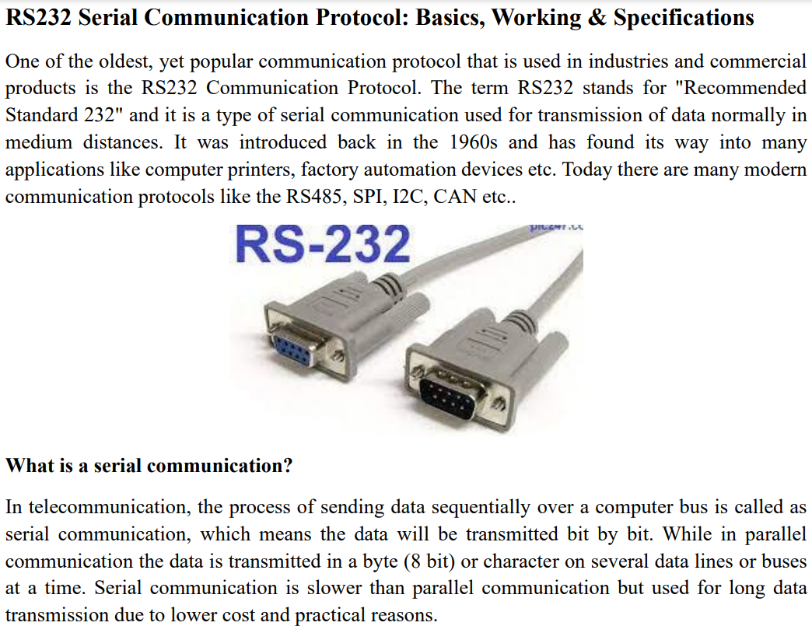

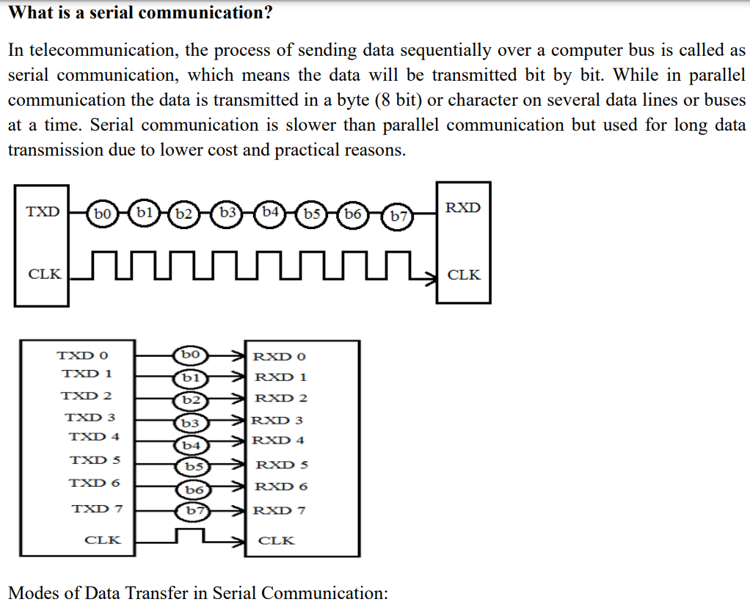

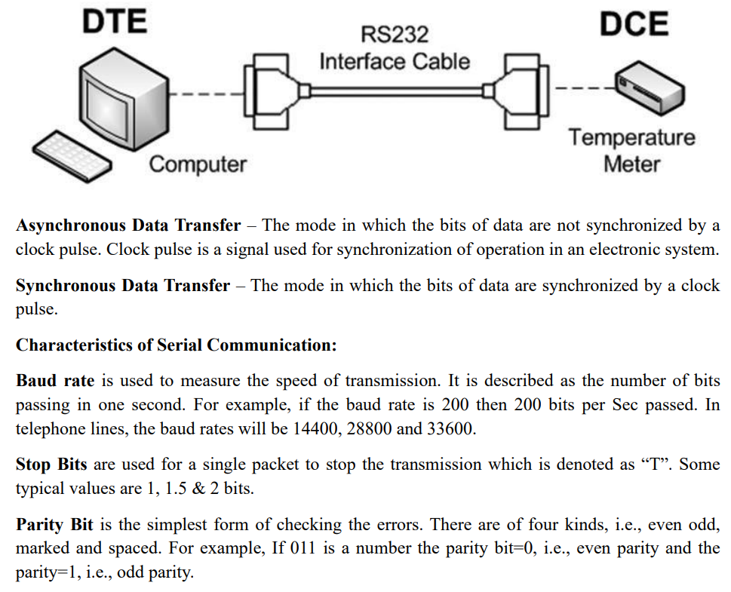

Working:

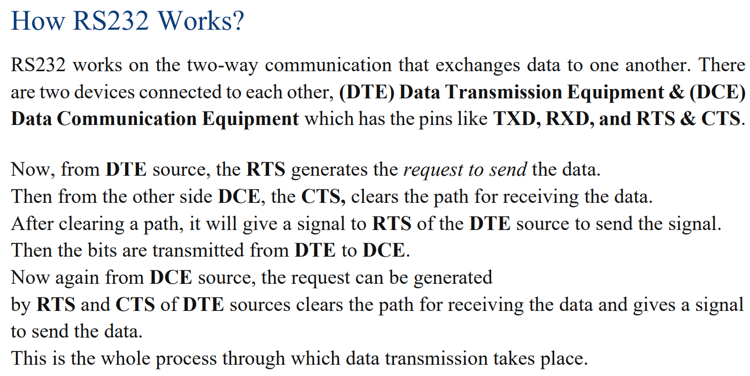

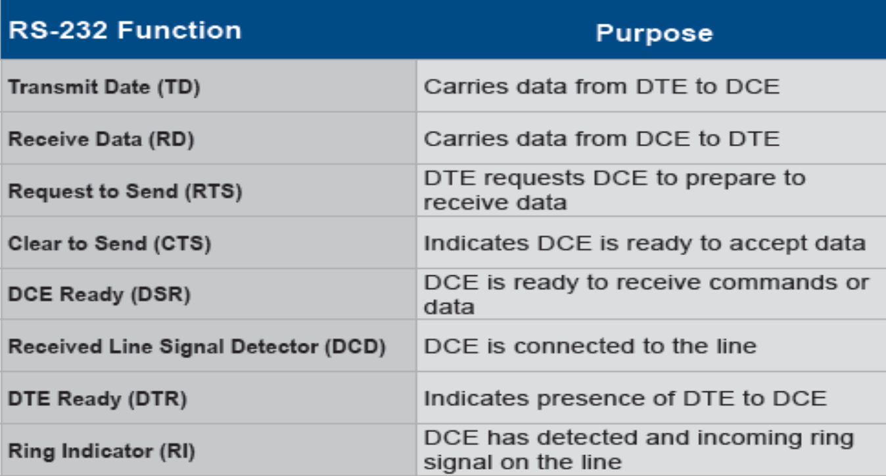

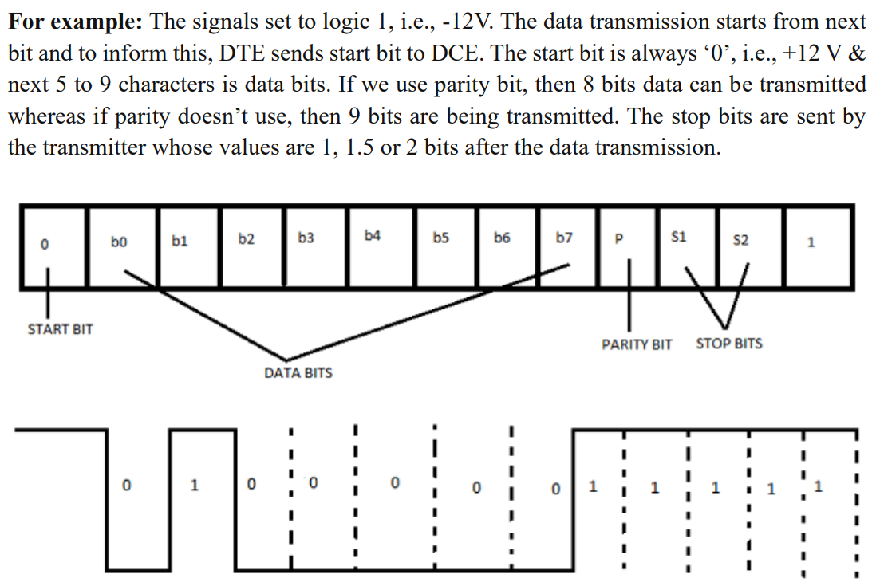

Specification:

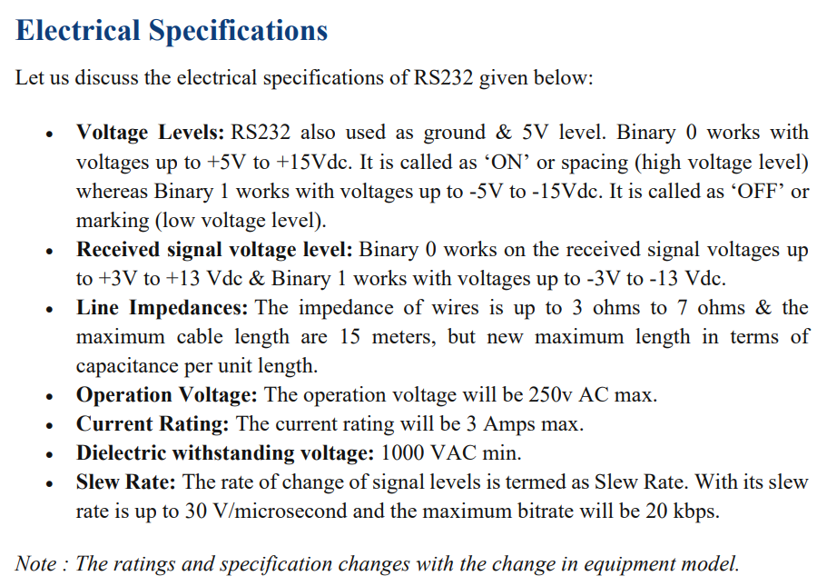

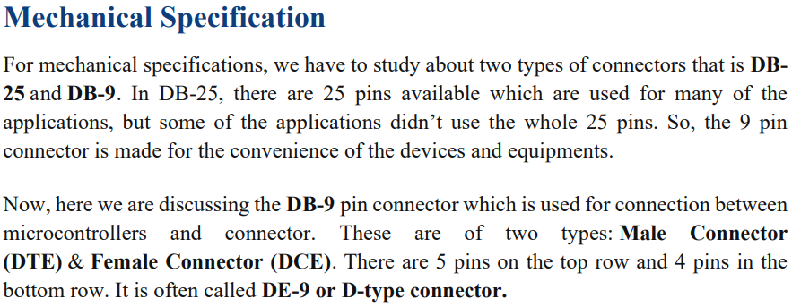

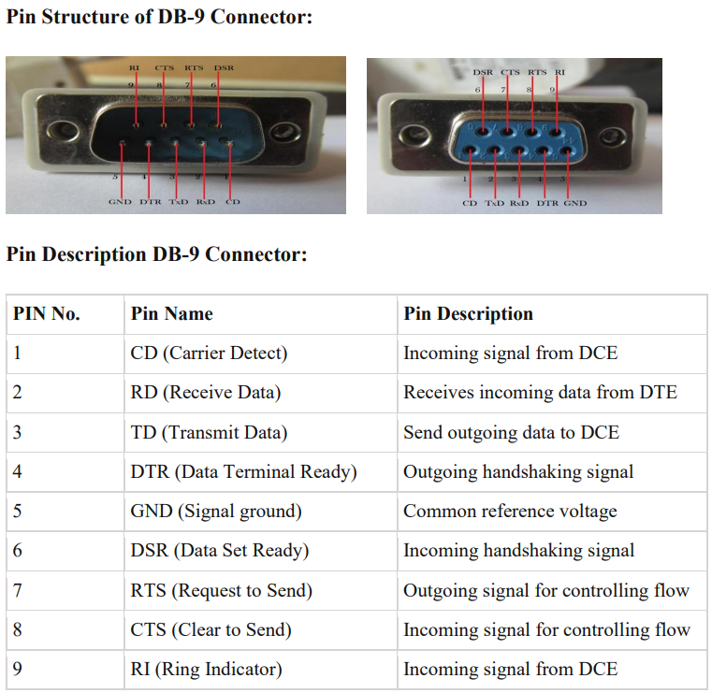

## In the early days of color television, a major hurdle was ensuring everyone could enjoy the new technology. How did engineers design color TV systems to be compatible with existing black-and-white televisions?

To ensure that color television technology could be adopted universally without making existing black-and-white televisions obsolete, engineers developed the following solutions:

**1. Use of Luminance Signal (Y)**

* Engineers used a **luminance (Y)** signal to represent the brightness information of the image.
* The luminance signal was calculated as: Y=0.3VR+0.59VG+0.11VBY = 0.3V_R + 0.59V_G + 0.11V_B​
* Black-and-white TVs only processed the luminance signal, so they could display a grayscale version of the color broadcast without any changes.

**2. Addition of Chrominance Signals (U and V)**

* To include color information, engineers introduced **chrominance (color difference)** signals:
  + U=VB−Y (Blue difference)
  + V=VR−Y (Red difference)
* These signals carried color details but did not interfere with the luminance signal.

**3. Frequency Division Multiplexing**

* The chrominance signals were modulated onto a **subcarrier frequency** that was outside the range of luminance frequencies.
* This ensured that the luminance and chrominance signals could coexist without causing interference.
* Black-and-white TVs ignored the subcarrier, processing only the luminance signal.

**4. NTSC, PAL, and SECAM Standards**

* Standards like NTSC, PAL, and SECAM were developed to ensure compatibility across different regions while maintaining the backward compatibility with black-and-white TVs.
* These systems encoded luminance and chrominance in a way that older TVs could still process the broadcast correctly.

**5. Color Burst Signal**

* A **color burst signal** was added to the transmission to help color TVs synchronize with the chrominance signal.
* Black-and-white TVs ignored this signal, ensuring uninterrupted viewing.

**6. Maintaining Aspect Ratio and Resolution**

* The aspect ratio (4:3) and resolution used in black-and-white broadcasts were retained in color TV systems to avoid compatibility issues.

**7. Gradual Transition Period**

* Engineers ensured that color TV broadcasts were compatible with existing black-and-white infrastructure to facilitate a gradual adoption of color TVs.
* Broadcasters continued to produce content that could be enjoyed on both types of TVs.

**Summary**

By carefully integrating luminance and chrominance signals and using frequency division multiplexing, engineers ensured that:

1. Black-and-white TVs could display the luminance signal without any modifications.
2. Color TVs could decode both luminance and chrominance signals for full-color viewing.

## Explain the basic characteristics of sound signals using appropriate definitions and examples.

## Loudness

## Pitch

## Frequency Response

## Fidility

## Sensitivity of Human ear for Sound

**Basic Characteristics of Sound Signals**

1. **Loudness**:
   * **Definition**: Loudness is the perception of the intensity of a sound. It is how we perceive the strength or amplitude of sound waves.
   * **Example**: A whisper has low loudness, while a shout has high loudness.
   * **Explanation**: Loudness is measured in decibels (dB). The human ear can typically hear sounds ranging from 0 dB (the threshold of hearing) to about 120 dB (the threshold of pain).
2. **Pitch**:
   * **Definition**: Pitch is the perception of the frequency of a sound. It determines how high or low a sound is.
   * **Example**: The sound of a flute has a high pitch, while the sound of a bass drum has a low pitch.
   * **Explanation**: Pitch is measured in Hertz (Hz). Higher frequencies correspond to higher pitches, and lower frequencies correspond to lower pitches. The human ear can typically hear frequencies from 20 Hz to 20,000 Hz.
3. **Frequency Response**:
   * **Definition**: Frequency response is the measure of an audio system's ability to reproduce all frequencies equally.
   * **Example**: A high-quality speaker system has a flat frequency response, meaning it can reproduce low, mid, and high frequencies accurately.
   * **Explanation**: Frequency response is often represented as a graph showing the output level of a system across a range of frequencies. A flat frequency response indicates that the system reproduces all frequencies at the same level.
4. **Fidelity**:
   * **Definition**: Fidelity refers to the accuracy with which an audio system reproduces the original sound.
   * **Example**: High-fidelity (hi-fi) audio equipment aims to reproduce sound as close to the original recording as possible.
   * **Explanation**: High fidelity means minimal distortion and noise, ensuring that the reproduced sound is a true representation of the original.
5. **Sensitivity of Human Ear for Sound**:
   * **Definition**: Sensitivity of the human ear refers to its ability to detect and respond to different sound levels and frequencies.
   * **Example**: The human ear is more sensitive to frequencies between 2,000 and 5,000 Hz, which is why these frequencies are often perceived as louder.
   * **Explanation**: The sensitivity of the human ear varies across different frequencies. The ear is most sensitive to sounds in the mid-frequency range and less sensitive to very low or very high frequencies. This sensitivity is often represented by the equal-loudness contour, which shows the ear's response to different frequencies at various loudness levels.

## What kinds of mobile wearable devices can be used to improve a person's health and/or a medical condition? Explain with examples.

There are 2 main types of these devices - those used for health-conscious consumers and those for medical reasons.

1. **Health Wearables:**
   * **Commercially Sold Health Wearables:**
     + Devices like FitBit that track users' everyday activities, exercise levels, and vital statistics.
   * **Smartphone Apps and Chatbots:**
     + Examples include Alexa on the Amazon Echo and Dot, Siri, Cortana, etc.

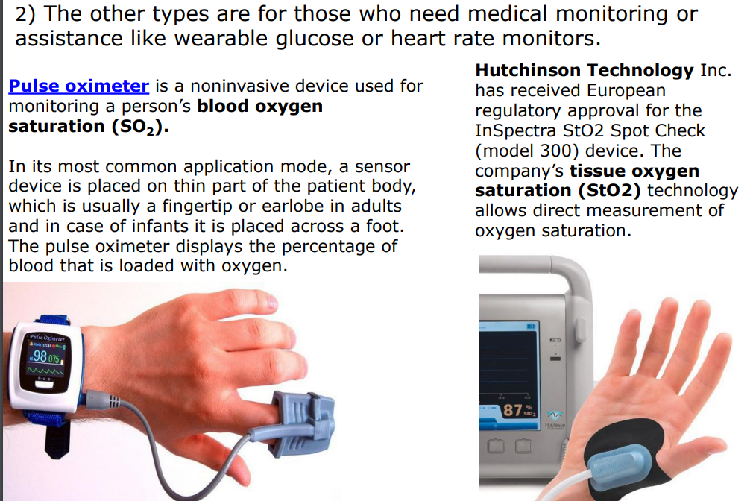

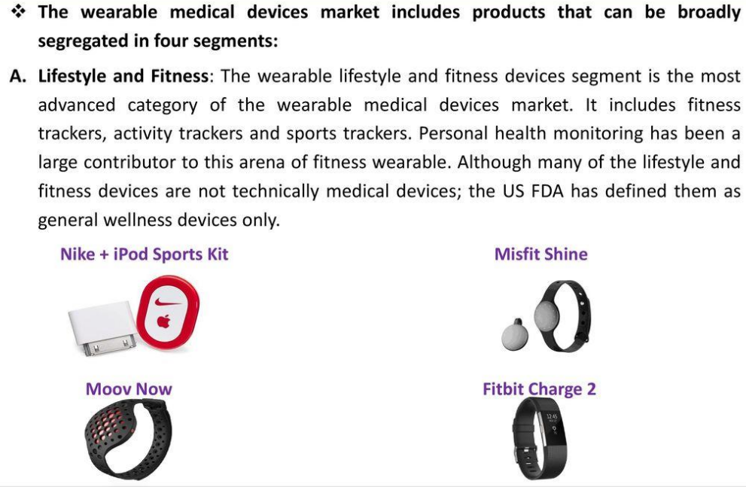

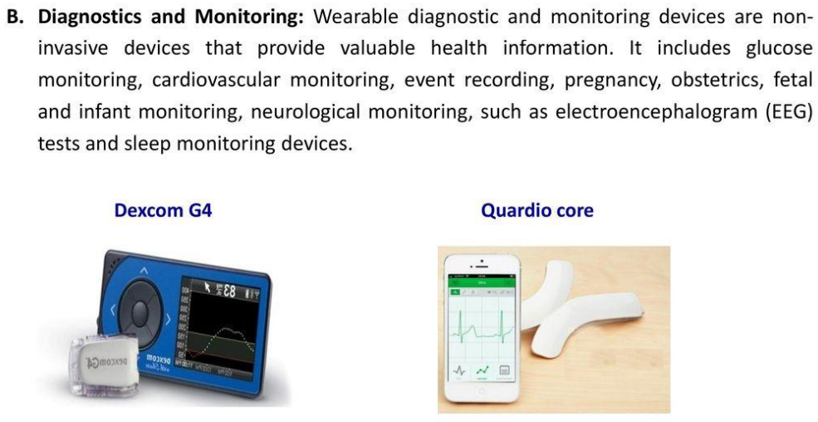

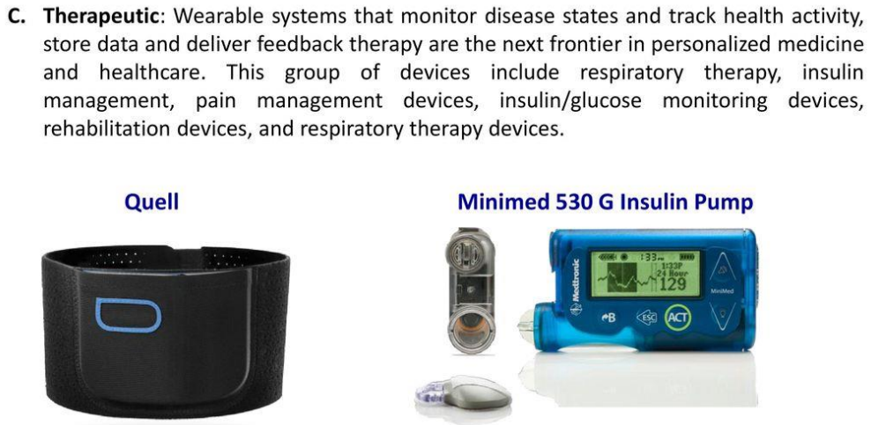

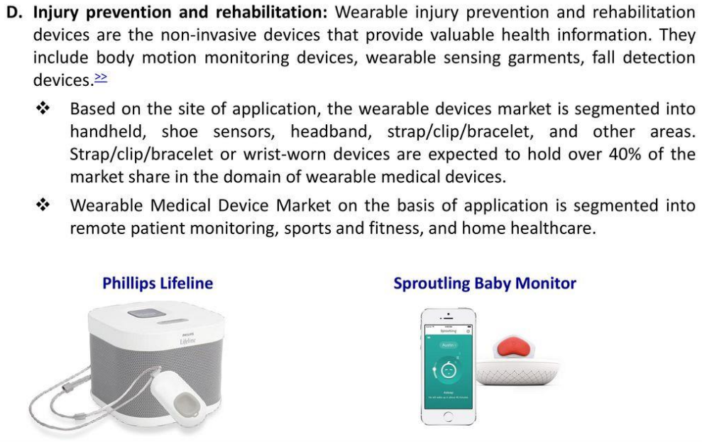

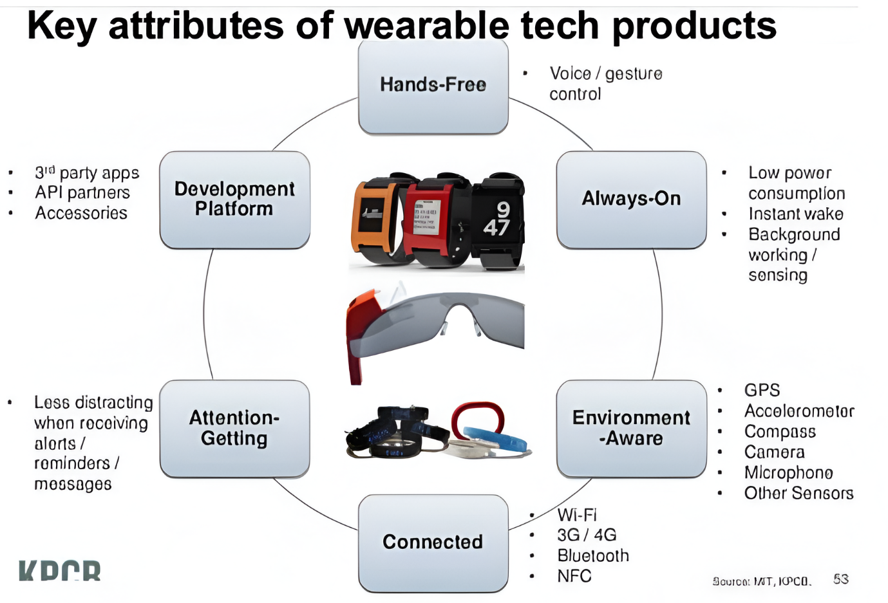

## Draw a labeled diagram of an ECG waveform, and briefly explain the following components: P wave, PR interval, QRS complex, ST segment, QT interval, and T wave.

What are the components

● It is waveform components that consist of the electrical events during one heartbeat

● The waveforms are labeled as P, Q, R, S, T and U.

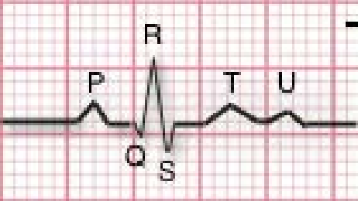

**P wave**

● P wave is the first short upward movement of the ECG tracing. It indicates that the atria are contracting, pumping blood into the ventricles.

● Amplitude: 2-3 mm high

The P-wave should be 2–3 small squares in duration

Duration: 0.06 - 0.12 sec

**QRS complex**

● The QRS complex, normally beginning with a downward deflection, Q; a larger upwards deflection, a peak (R); and then a downwards S wave. The QRS complex represents ventricular depolarization and contraction.

● Amplitude: 5-30 mm high

The QRS complex should be 1.5–2.5 small squares in duration

Duration: 0.06 - 0.10 sec

**PR interval**

● The PR interval indicates the transit time for the electrical signal to travel from the sinus node to the ventricles.

● Duration: 0.012 - 0.20 sec

● The PR interval should be 3–5 squares in duration

**QT interval**

● The QT interval should be 9–11 small squares

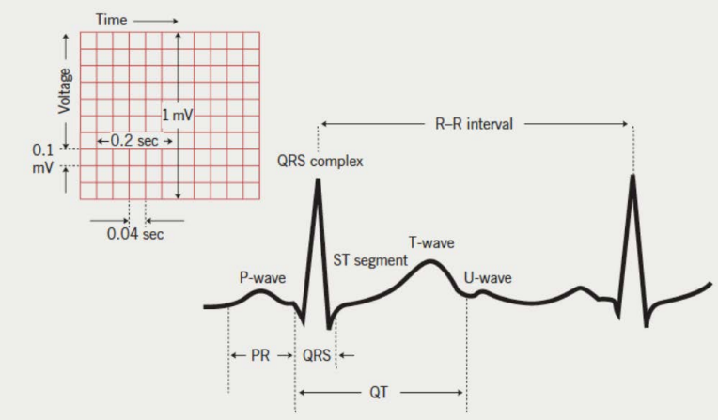

T wave

● T wave is normally a modest upwards waveform representing ventricular repolarization

● Amplitude: 0.5 mm in limb leads

Duration: 0.1 - 0.25 sec

## What specific components make up a CCTV system and how are they utilized in surveillance setups?

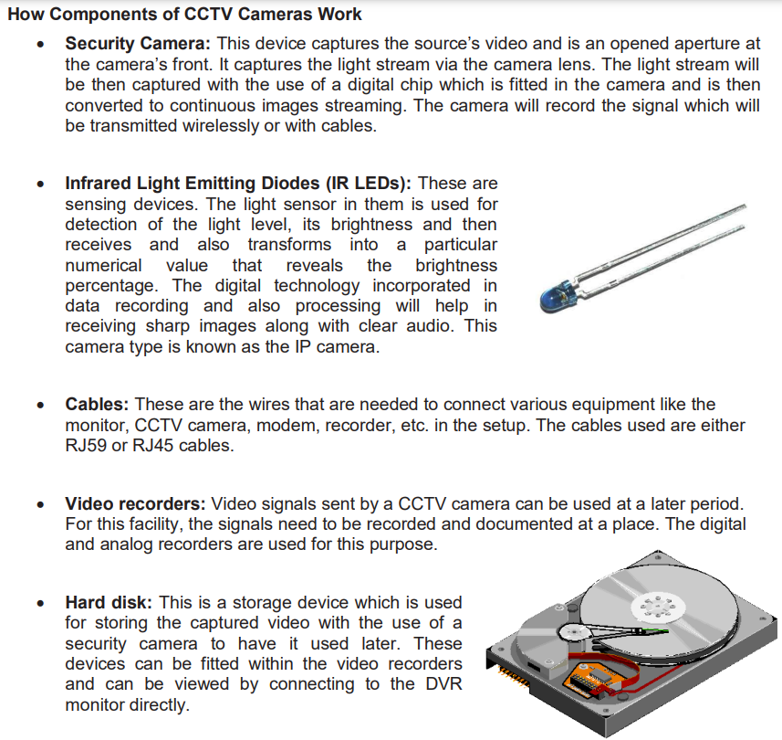

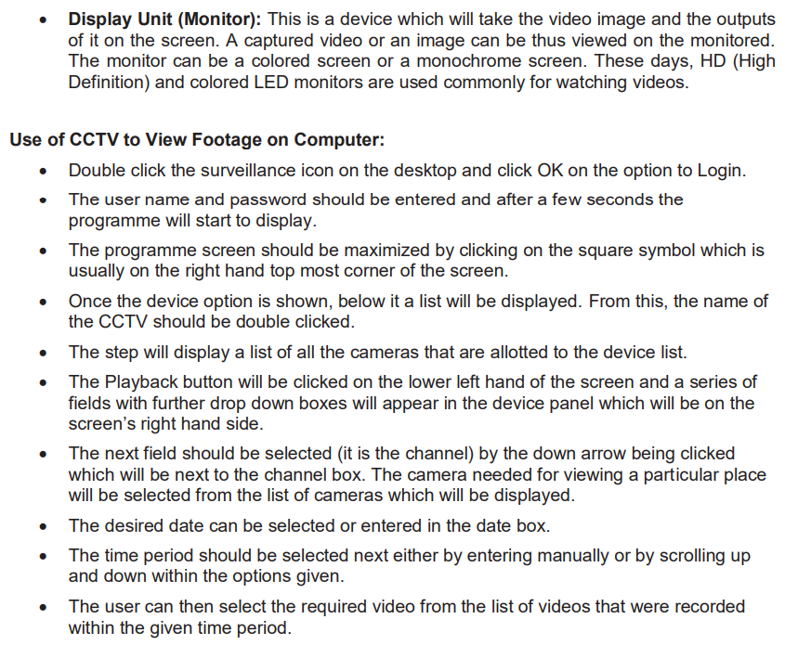



**1. Uniqueness**

* Each individual's biometric trait must be unique.
* Examples: No two individuals have the same fingerprint, iris pattern, or voice characteristics.

**2. Universality**

* The biometric trait must be present in all individuals.
* Example: Fingerprints, facial features, or voice are available in every individual for identification.

**3. Permanence**

* The biometric trait should remain consistent over time.
* Example: Fingerprints and iris patterns generally do not change with age.

**4. Measurability**

* The biometric trait must be measurable and quantifiable using sensors or devices.
* Example: Fingerprint scanners, iris scanners, and voice recognition systems.

**5. Accuracy**

* The system should provide high accuracy with low error rates:
  + **False Acceptance Rate (FAR):** The probability of an unauthorized user being accepted.
  + **False Rejection Rate (FRR):** The probability of an authorized user being rejected.
* Effective biometrics minimize both FAR and FRR.

**6. Acceptability**

* The system must be user-friendly and accepted by individuals.
* Example: Facial recognition is more acceptable compared to invasive methods like DNA sampling.

**7. Security**

* The biometric system should be resistant to spoofing or duplication.
* Example: Advanced fingerprint scanners can detect fake fingerprints.

**8. Scalability**

* The system should be scalable to support a large number of users in a network.
* Example: Cloud-based biometric databases can handle millions of users.

**9. Speed**

* The system must authenticate users quickly to ensure smooth access without delays.
* Example: Real-time facial recognition systems process data within milliseconds.

**10. Integration with Existing Systems**

* The biometric system should integrate seamlessly with existing network security infrastructure.
* Example: Multi-factor authentication systems combining passwords and biometrics.

**11. Cost-Effectiveness**

* The biometric system must provide a balance between performance and affordability.
* Example: Fingerprint scanners are widely used because of their low cost and reliability.

**12. Data Privacy and Protection**

* The system must ensure that biometric data is stored securely and complies with privacy regulations.
* Example: Using encryption and secure servers to protect biometric templates.

## Explain with neat diagram how color television camera system generates color signals (Y) = 0.3V_R + 0.59V_G + 0.11V_B?

**1. Basic Concept of Color Signal Generation**

* A color television system generates three primary signals corresponding to the Red (R), Green (G), and Blue (B) components of a scene.
* These three signals (VR, VG, VB) are combined to produce a **luminance (Y)** signal and two chrominance signals for transmission.
* The luminance signal, **Y**, represents the overall brightness of the image and is calculated as: Y=0.3VR+0.59VG+0.11VB​ .This formula is based on human eye sensitivity, where the green component contributes the most to brightness.

**2. Components of a Color Television Camera**

* **Camera Lens**: Focuses the scene onto a beam-splitting prism.
* **Beam-Splitting Prism**: Separates the incoming light into its primary color components (Red, Green, Blue).
* **Color Filters**: Allow only specific wavelengths corresponding to the R, G, and B components.
* **Image Sensors (CCD or CMOS)**: Convert the optical signals for R, G, and B into electrical signals, producing VR, VG, and VB.

**3. Signal Generation Process**

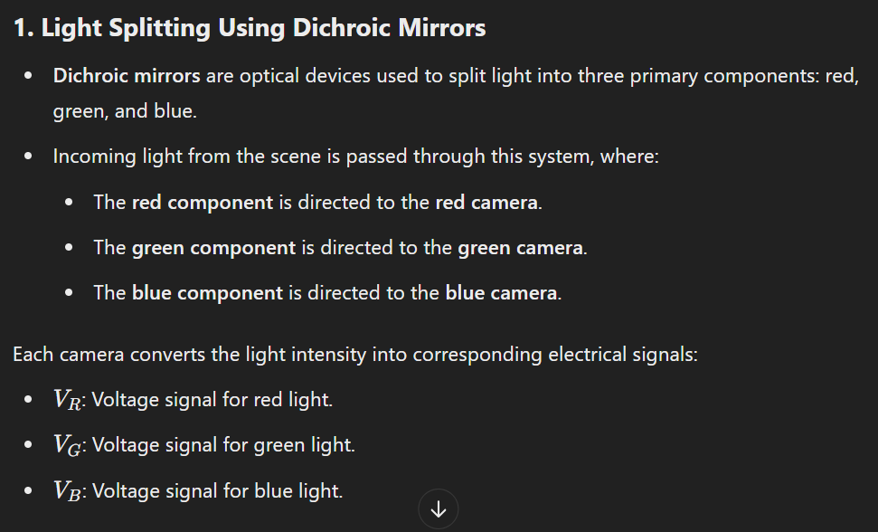

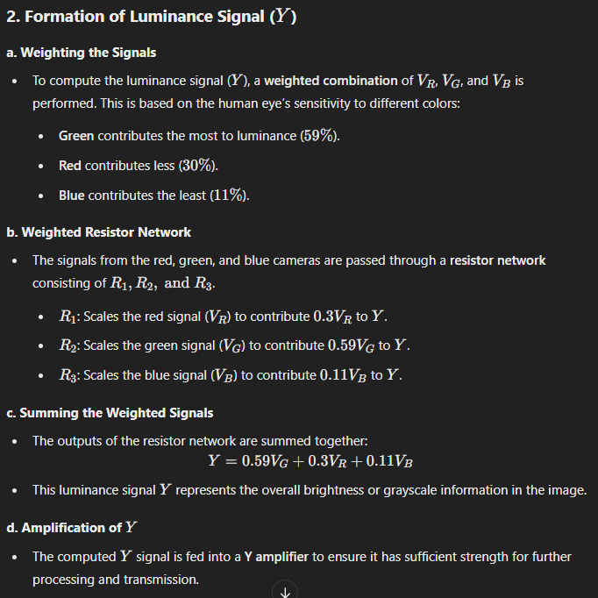

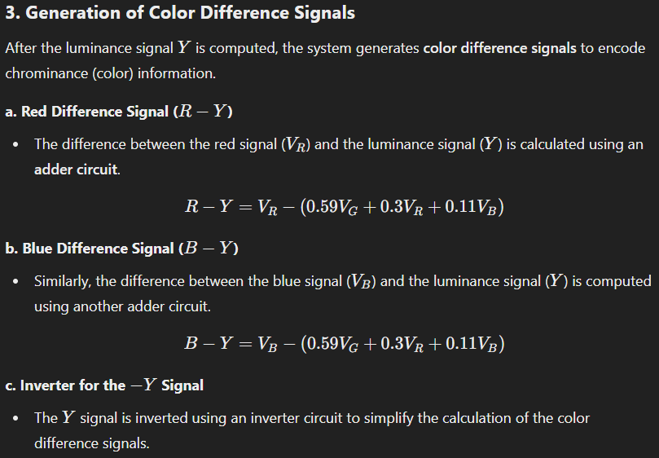

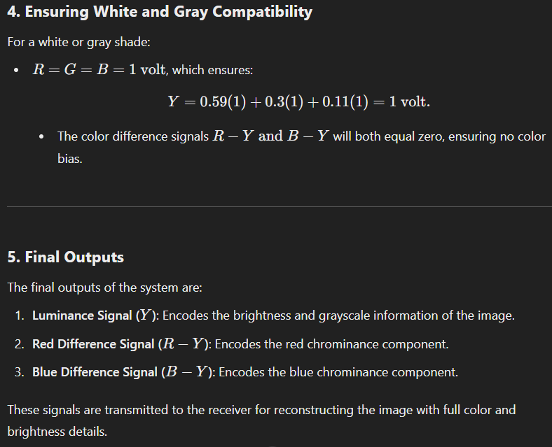

**4. Importance of Luminance (Y)**

* The luminance signal is crucial because:
  + It carries the brightness details of the scene.
  + It is used in black-and-white televisions for backward compatibility.

**5. Chrominance Signal**

* After generating the luminance signal, the camera also generates **chrominance (color difference)** signals:
  + U=VB−Y (Blue difference)
  + V=VR−Y (Red difference)
* These signals represent the color information and are transmitted along with the luminance signal.

**6. Advantages of This Method**

* Backward Compatibility: The luminance signal (Y) ensures compatibility with black-and-white TVs.
* Reduced Bandwidth: Combining Y with chrominance signals minimizes bandwidth requirements compared to transmitting R, G, and B separately.

**7. Neat Diagram for Signal Generation**

Include a labeled diagram showing the flow of light from the lens to the sensors and how VR, VG, VB, Y, U, and V signals are generated. Your diagram should look like this:

* **Lens** → **Beam-Splitting Prism** → **Color Filters (R, G, B)** → **Image Sensors (CCD/CMOS)** → **Signal Matrix** (generating Y, U, V).

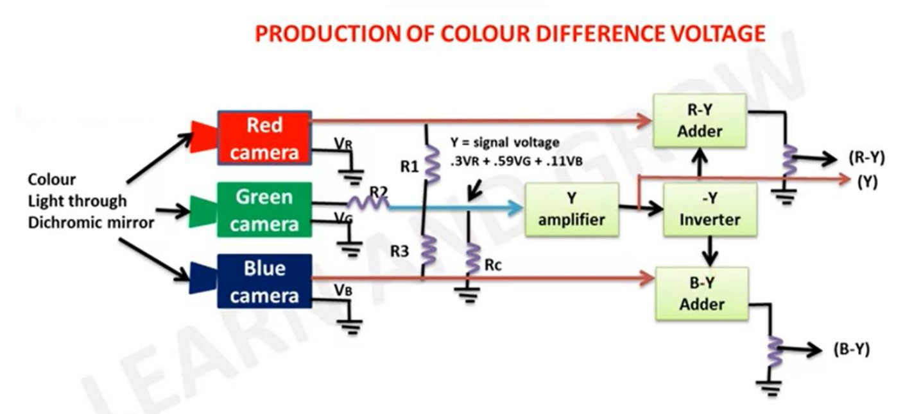

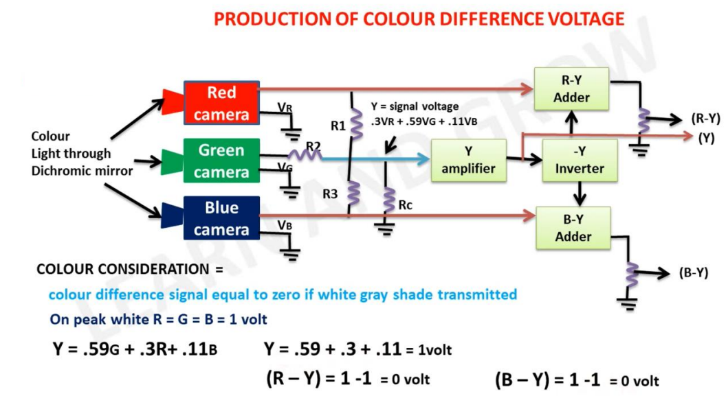

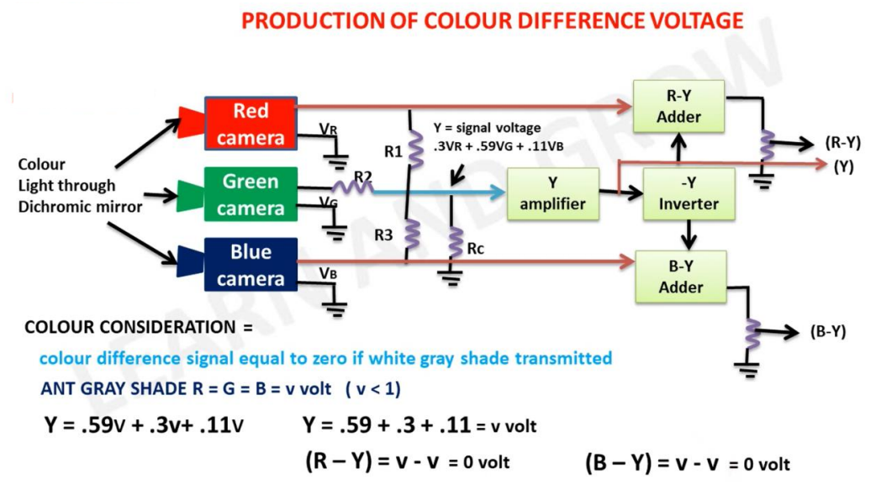

## Explain the block diagram of NTSC Encoder. Also compare NTSC and PAL system.

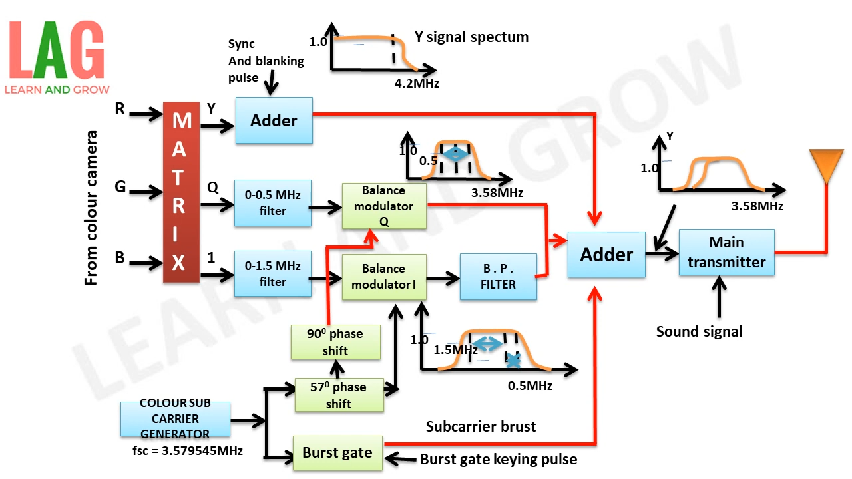

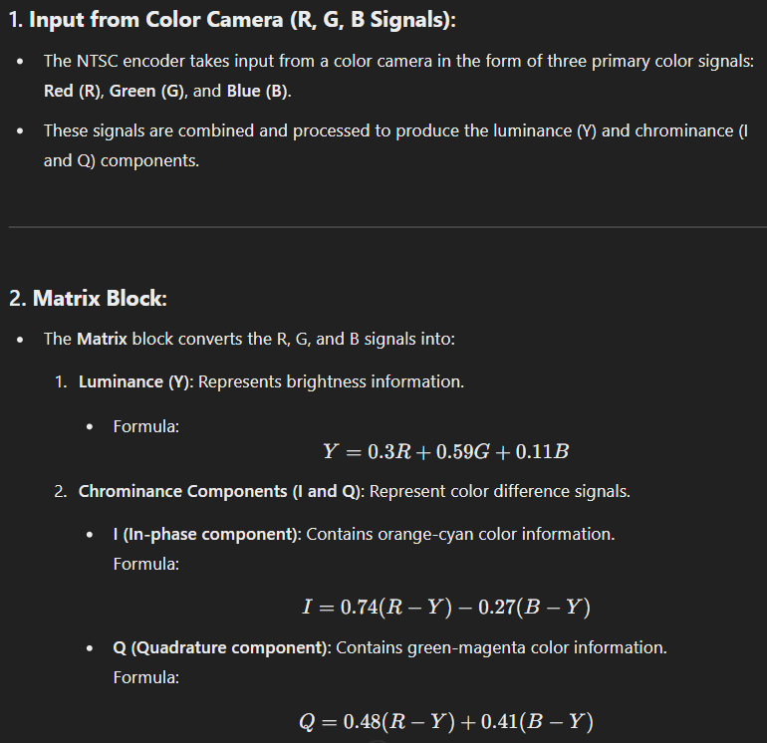

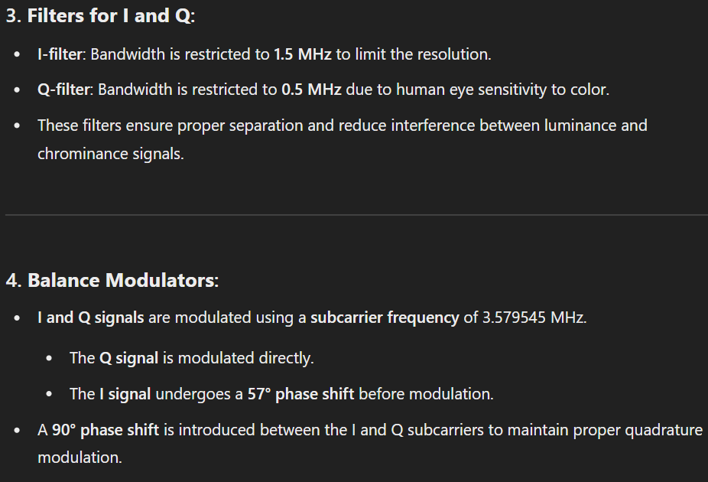

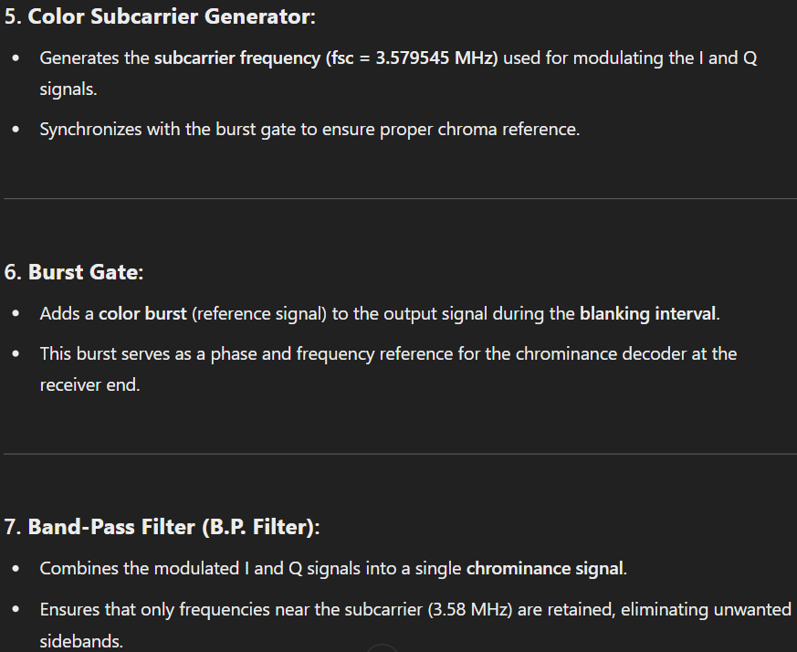

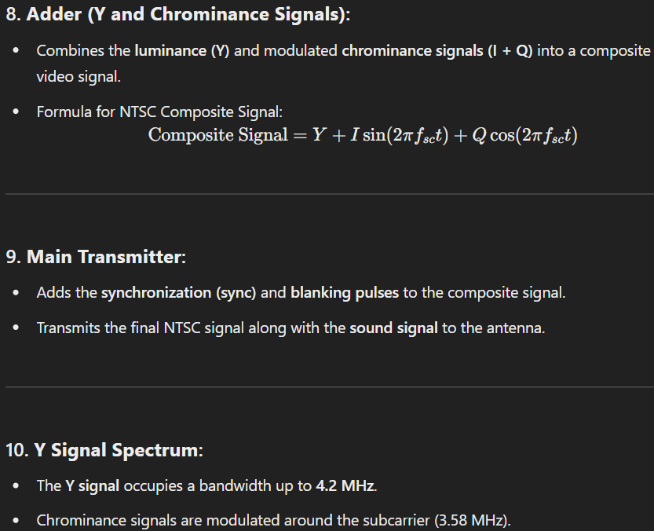

**11. Flow of the Diagram:**

1. The R, G, and B signals are processed in the Matrix to obtain Y, I, and Q.
2. The I and Q signals pass through their respective filters.
3. The modulated I and Q signals are combined and filtered using the B.P. filter.
4. The Y signal is added to the chrominance signal.
5. Sync and blanking pulses are added to form the final composite NTSC signal.
6. The signal is transmitted to the antenna for broadcast.

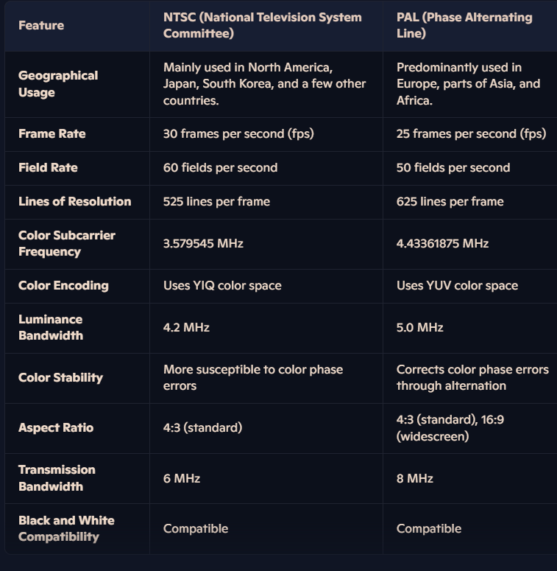

# ESE JULY 2019

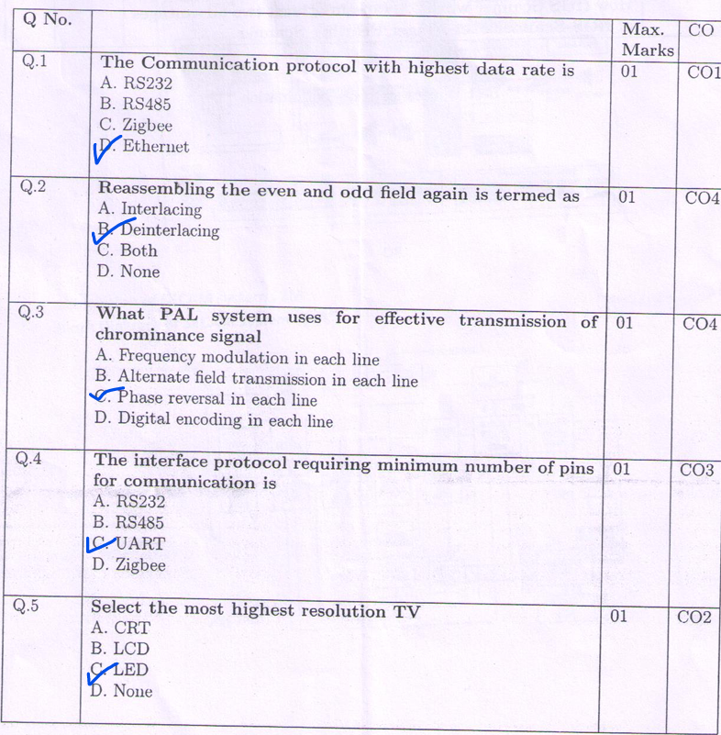

## How IRIS Scanner works. Explain at least two advantages of IRIS Scanner over Finger Printing Scanner

**How an IRIS Scanner Works:**

1. **Image Capture**:
   * The scanner uses a high-resolution infrared camera to capture detailed images of the iris, the colored portion of the eye surrounding the pupil.
   * Infrared light enhances the visibility of intricate patterns in the iris, even for individuals with dark-colored irises.
2. **Pattern Recognition**:
   * The captured image is processed to extract unique patterns, such as furrows, rings, and freckles, which are then converted into a digital template.
3. **Matching Process**:
   * The digital template is compared against stored templates in a database to authenticate the individual. The matching algorithm ensures a high degree of accuracy due to the uniqueness of iris patterns.
4. **Non-Intrusive Process**:
   * The process is non-contact, requiring the user to stand a short distance from the scanner, making it hygienic and convenient.

**Advantages of IRIS Scanners Over Fingerprint Scanners:**

1. **Higher Accuracy and Uniqueness**:
   * **Iris Patterns**: The iris has more unique and complex patterns than fingerprints, making it less likely for two individuals to have identical iris patterns.
   * **False Rejection/Acceptance Rate**: Iris scanners typically have lower false rejection and false acceptance rates compared to fingerprint scanners.
2. **Less Susceptible to Wear and Tear**:
   * **Fingerprints**: Physical activities, aging, or injuries can alter fingerprints, affecting the accuracy of fingerprint scanners.
   * **Iris**: The iris remains relatively unchanged over a person’s lifetime and is less likely to be affected by external factors, ensuring consistent performance.

**Additional Benefits of IRIS Scanners:**

* Non-contact operation reduces hygiene concerns.
* Works well for individuals with dirty, wet, or damaged fingers where fingerprint scanning may fail.
* Effective in high-security applications such as airports, banking, and national identification systems.

## Describe the operation of Hi-Fi System with neat, labelled diagram.

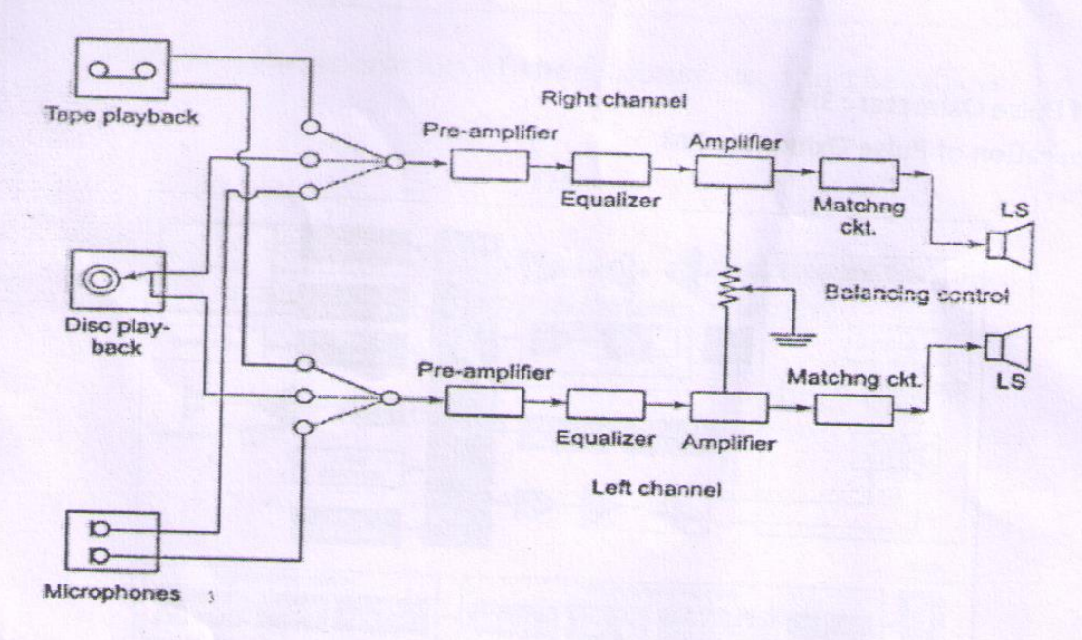

**Key Components and Their Functionality:**

1. **Input Sources:**
   * **Tape Playback:** Represents the input from a tape recorder or player.
   * **Disc Playback:** Represents the input from a record player.
   * **Microphones:** Allows real-time audio input.

The user can select any of these input sources to feed the system.

1. **Preamplifiers:**
   * The signals from the input sources are fed into preamplifiers.
   * Preamplifiers boost the low-level signals from the inputs (microphones, tape, or disc) to a usable level without introducing noise or distortion.
2. **Equalizers:**
   * The output from the preamplifiers is sent to the equalizers.
   * Equalizers adjust the frequency response of the audio signal, enabling customization of the sound quality (e.g., bass, midrange, treble adjustments).
3. **Amplifiers:**
   * The equalized signal is further amplified to a level that can drive the speakers.
   * Amplifiers ensure the sound has sufficient power for playback at various volume levels.
4. **Balancing Control:**
   * The balancing control allows adjustment of the output levels between the left and right channels, ensuring proper stereo imaging.
5. **Matching Circuits:**
   * Matching circuits ensure that the output impedance matches the speaker's input impedance, preventing power loss and distortion.
6. **Loudspeakers (LS):**
   * The final amplified signal is sent to the loudspeakers for sound reproduction.
   * Separate loudspeakers are used for the left and right channels, creating a stereo effect.

**Stereo Configuration:**

* The system processes audio in two channels (left and right) for stereo sound.
* Each channel (right and left) follows a similar processing path: preamplifier → equalizer → amplifier → matching circuit → loudspeaker.

## Describe the operation of the Pulse Oximeter with neat, labelled diagram.

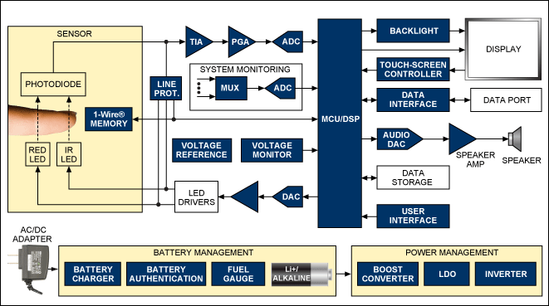

1. Sensor Probe Placement:
   * The user places the pulse oximeter's sensor probe, which contains the red and infrared LEDs as well as the photodetector, on the patient's finger, earlobe, or other suitable body part.
   * The probe is designed to fit snugly around the measurement site to ensure good contact and optimal light transmission.
2. Light Emission and Absorption:
   * The red and infrared LEDs in the sensor probe flash light of specific wavelengths through the skin and underlying blood vessels.
   * As the blood pulses through the vessels, the amount of light absorbed by the blood changes. Oxygenated hemoglobin (HbO2) and deoxygenated hemoglobin (Hb) have different light absorption characteristics.
3. Photodetection:
   * The photodetector in the sensor probe measures the changes in light absorption as the blood pulses.
   * The photodetector converts the detected light signals into electrical currents, which are then amplified and processed.
4. Signal Processing:
   * The electrical signals from the photodetector are first passed through a transimpedance amplifier (TIA), which converts the small photodetector currents into measurable voltages.
   * Next, a programmable gain amplifier (PGA) boosts the amplified signals to a level suitable for analog-to-digital conversion.
   * The amplified signals are then digitized by an analog-to-digital converter (ADC), allowing a microcontroller or digital signal processor (MCU/DSP) to analyze the data.
5. Oxygen Saturation Calculation:
   * The MCU/DSP uses the digitized red and infrared light absorption data to calculate the ratio of oxygenated to total hemoglobin in the blood.
   * This ratio is directly related to the patient's oxygen saturation level (SpO2), which is typically expressed as a percentage.
   * The algorithm used by the MCU/DSP to derive the SpO2 value is based on established principles of light absorption in biological tissues.
6. Heart Rate Determination:
   * In addition to oxygen saturation, the pulse oximeter also determines the patient's heart rate.
   * It does this by analyzing the pulsatile changes in the light absorption signals, which correspond to the rhythmic contraction and expansion of the blood vessels with each heartbeat.
   * The MCU/DSP can extract the heart rate information from the processed light absorption data.
7. Display and User Interface:
   * The calculated oxygen saturation percentage and heart rate values are then displayed on the pulse oximeter's screen or interface.
   * The device may also provide visual or auditory alerts if the measured values fall outside of normal ranges.
   * Users can interact with the pulse oximeter through touch controls or other input mechanisms to adjust settings, review data, or access additional features.

Throughout this process, the pulse oximeter's power management system ensures efficient operation, often using a rechargeable battery and power-saving techniques. The device may also offer data connectivity options to allow sharing of the measured vital signs with other medical systems or devices.

## Describe the operation of the Scanner used in the offices.

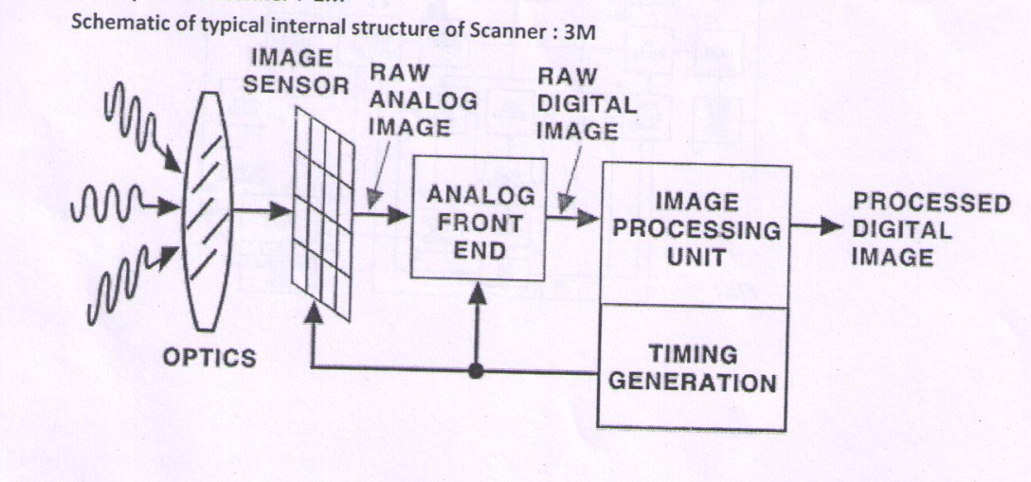

• Optics:

* The optics section is responsible for capturing the light or image that is to be scanned.
* It includes lenses, mirrors, and other optical components that focus and direct the light onto the image sensor.

• Image Sensor:

* The image sensor, also known as the CCD (Charge-Coupled Device) or CMOS (Complementary Metal-Oxide-Semiconductor) sensor, is the core component of the scanner.
* It converts the optical image into an electrical signal, which is then processed further.

• Raw Analog Image:

* The image sensor outputs a raw analog image, which is an unprocessed electrical representation of the captured optical image.

• Analog Front End:

* The analog front end is responsible for conditioning the raw analog image signal.
* It may perform tasks such as amplification, filtering, and analog-to-digital conversion to prepare the signal for digital processing.

• Raw Digital Image:

* The conditioned analog image signal is then converted to a raw digital image, which is a numerical representation of the scanned image.

• Image Processing Unit:

* The image processing unit is where the raw digital image undergoes various processing steps, such as color correction, sharpening, and noise reduction.
* This unit applies algorithms and techniques to enhance the image quality and prepare it for final output.

• Timing Generation:

* The timing generation module is responsible for synchronizing the various components of the scanner, ensuring that the image data is captured and processed correctly.

• Processed Digital Image:

* The final output of the scanner is the processed digital image, which is the result of all the previous steps and is ready for further use or output.

## Describe the Operation of SECAM Television standard.

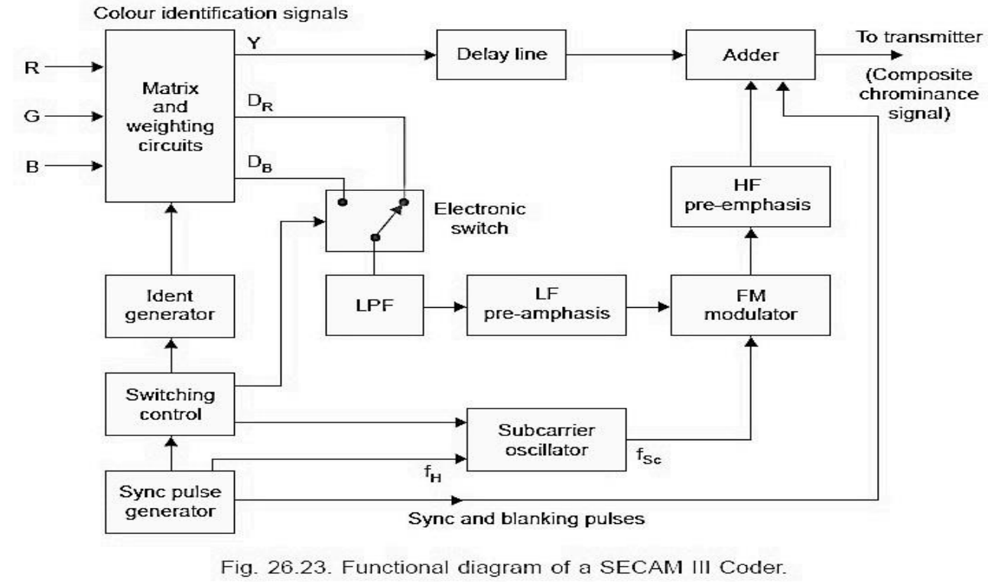

1. Input Signals:
   * The system receives three input signals - R (red), G (green), and B (blue) - which carry the color information from the source.
2. Matrix and Weighting Circuits:
   * These circuits take the R, G, and B input signals and perform a matrix transformation to derive the luminance (Y) and chrominance (R-Y, B-Y) components.
   * The weighting circuits ensure the proper balance and scaling of these derived signals.
3. Delay Lines:
   * The chrominance signals (R-Y and B-Y) are passed through delay lines, which introduce a precise time delay. This delay is necessary for proper color decoding later in the process.
4. Electronic Switch:
   * The electronic switch alternates between the R-Y and B-Y chrominance signals, creating a time-multiplexed signal.
5. Low-Pass Filter (LPF):
   * The time-multiplexed chrominance signal is passed through a low-pass filter to limit its bandwidth.
6. LF (Low Frequency) Pre-Emphasis:
   * The filtered chrominance signal undergoes low-frequency pre-emphasis, which boosts the low-frequency components. This helps improve the signal-to-noise ratio during transmission.
7. Adder:
   * The processed luminance (Y) signal and the time-multiplexed chrominance signal are combined in the adder to create the composite chrominance signal.
8. HF (High Frequency) Pre-Emphasis:
   * The composite chrominance signal is passed through a high-frequency pre-emphasis circuit, which boosts the high-frequency components. This further enhances the signal-to-noise ratio.
9. FM Modulator:
   * The pre-emphasized composite chrominance signal is then modulated onto a high-frequency carrier signal using frequency modulation (FM). This creates the final SECAM III signal ready for transmission.
10. Subcarrier Oscillator:
    * The subcarrier oscillator generates a precise reference frequency (fsc) that is used for synchronization and decoding at the receiver end.
11. Sync and Blanking Pulses:
    * The sync pulse generator creates the necessary synchronization and blanking pulses to ensure proper timing and synchronization of the video signal.
12. Switching Control:
    * The switching control unit coordinates the various switching operations, such as the electronic switch, to ensure the proper timing and sequencings of the signal processing.

By following this step-by-step process, the SECAM III color identification system takes the input RGB signals, extracts the luminance and chrominance components, processes them through various circuits, and ultimately generates the final composite chrominance signal that can be transmitted and decoded by the receiver. Each component plays a crucial role in shaping and optimizing the video signal to ensure accurate color reproduction and stable, high-quality video transmission.

CRT